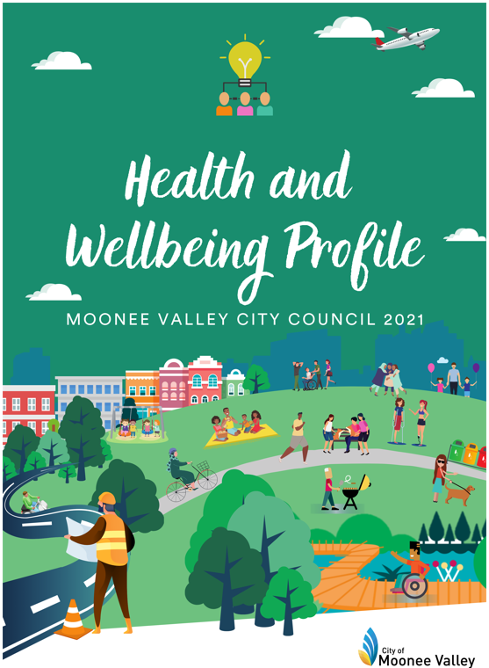

Acknowledgement of Country

Moonee Valley City Council respectfully acknowledges the Traditional Custodians of the land on which Moonee Valley is located – the Wurundjeri Woi-wurrung People of the Kulin Nation; and we pay our respects to their Spirits, Ancestors, Elders and Community Members past and present. Council also extends this respect to other Aboriginal and Torres Strait Islander Peoples who call Moonee Valley home.

August 2021

C

Executive summary

The Moonee Valley Health and Wellbeing Profile 2021 is an examination of data in relation to individual, economic, social, neighbourhood and environmental factors that influence health and wellbeing. These factors are known as determinants of health.

The City of Moonee Valley is a relatively advantaged municipality. However, it should be noted that Moonee Valley has sub-municipal levels of disadvantage, which means that not all residents experience positive health outcomes equally. This is referred to as health inequity.

Moonee Valley will continue to diversify and experience a range of challenges and opportunities that impact on the health and wellbeing of its residents, including recovery from the COVID-19 pandemic, increases in the cost of living, access to affordable housing, a growing and ageing population, increases in non-communicable diseases (such as depression and Alzheimer’s disease), and climate change impacts. Many of the challenges in improving health and reducing inequalities while balancing pandemic recovery efforts are common across Victoria. These challenges call for new and innovative approaches to ensure good health and wellbeing for those who live, work, learn and play in Moonee Valley.

Guided by the Social Determinants of Health Framework (socio-ecological framework) this profile identifies key considerations for health and wellbeing in Moonee Valley. A summary of demographic, socio-economic, environmental, and health and wellbeing findings are included in the following section. It is structured considering:
- Our People
- Our individual behaviours for health and wellbeing
- Living and working conditions
- Social and community networks
- Neighbourhood and environmental conditions
- Health and wellbeing outcomes

Summary statistics and emerging trends

Table 1: If our population were made-up of 100 people

Our people | Individual behaviours | Living and working conditions
Age:  29 aged less than 25  16 aged over 65 | Risky levels of alcohol consumption: 47 adults | Housing:  64 live in their own home  33 rent
CALD:  28 Live in households non-English speaking  6 Italian, 3 Greek, 2 Vietnamese, 2 Mandarin, 1 Cantonese and 1 Arabic  Flemington and Milleara have the highest number of people born overseas | Meet physical activity guidelines: 58 adults  Meet healthy eating guidelines: 3 adults  Smokers: 12 adults | Affordable and social housing:  4 live in public housing  2 available rental properties are affordable  40 Avondale Heights renters face rental stress
LGBTIQA+: 8 adults  International Students: 1 adult |  | Employed: 6 7 men; 59 women  The unemployment rate is highest in Flemington and Ascot Vale and lowest in Strathmore
1: Aboriginal and Torres Strait Islander |  | Weekly income >$1,250:  17 men; 10 women
Live with a disability: 5  45 People aged over 65 live with disability  10 Provide unpaid care for a person living with disability |  | Household structure:  31 couples with children  25 lone dwelling  Keilor Road/Essendon North highest proportion of people living alone

Note: Percentages have been rounded up to the whole number where applicable. Demographic and individual behavioural data was collected before the COVID-19 pandemic
Social & community networks | Neighbourhood conditions | Health and wellbeing outcomes
Feelings of safety walking alone at night:  32 women feel safe; 61 men feel safe  82 adults trust their neighbours  67 adults feel connected to their local community  Strathmore heights felt the most connected and the least connected was Avondale heights  18 Volunteer  21 households don’t have internet access | 19 adults travel to work by public transport  High levels of neighbourhood disadvantage in some areas  i.e. Flemington, Ascot Vale, Avondale Heights and Milleara | 70 adults rate their general health as good or very good  30 adults diagnosed with anxiety or depression  20 young people are psychologically distressed  46 unintentional injuries requiring hospitalisation caused by falls  13 deaths attributed to coronary heart disease

Table 1 continued: If our population were made-up of 100 people

Note: Percentages have been rounded up to the whole number where applicable. Demographic and individual behavioural data was collected before the COVID-19 pandemic.

Table 2: Emerging health and wellbeing trends and issues

Our people | Individual Behaviours | Living and Working Conditions
Ageing population | Increasing frequency of alcohol related hospital admissions | Higher levels of housing stress
Living alone increasing

Social & community networks | Neighbourhood Conditions | Health and Wellbeing Outcomes
Family violence increasing | Increase in health impacts of climate change (heatwaves and extreme heat, flooding and storm events, drought and reduced rainfall, air quality, greenhouse gas emissions,) | Psychological distress increasing  Self-reported general health is worsening
 |  | Alzheimer’s disease increasing
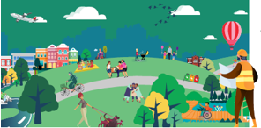

Contents

Acknowledgement of Country i
Executive summary 1
Summary statistics and emerging trends 2
Contents 5
1. Introduction 6
2. Our people 16
3. Individual behavioural factors influencing health and wellbeing 33
4. Individual living and working conditions 45
5. Social and community networks 58
6. Neighbourhood and environmental conditions 65
7. Health and wellbeing outcomes 75
Abbreviations 92
References 93
Appendices 99

Introduction

Policy context
The Victorian Local Government Act 2020 acknowledges the important role Council has to play in planning for the community. Councils are tasked with engaging and representing community interests when making decisions through planning, services and local law making. This includes a specific responsibility to improve the overall quality of life of people in the local community.
This responsibility is reinforced by the Victorian Public Health and Wellbeing Act 2008 and requires that when developing a Council Plan, councils include an analysis of data to gain a preliminary understanding of the health and wellbeing status of the community and the determinants or factors that contribute to this status. The Moonee Valley Health and Wellbeing Profile 2021 fulfils this purpose and is one of a suite of documents that will inform the development of the Council Plan 2021-25.
In addition to addressing local needs, the Council Plan must take into regard the Victorian Public Health and Wellbeing Plan 2019–23. The Victorian Public Health and Wellbeing Plan (VPHWP) identifies state level priorities for improvement of public health and wellbeing outcomes for all Victorians. There are ten priority areas, with state level focus areas indicated with an asterix (*):
- Tackling climate change and its impact on health*
- Reducing injury in the community
- Preventing all forms of violence
- Increasing healthy eating*
- Decreasing the risk of drug-resistant infections in the community
- Increasing active living*
- Improving mental wellbeing
- Improving sexual and reproductive health
- Reducing tobacco-related harm*
- Reducing harmful alcohol and drug use
These priorities are reflected in the data collected in this profile, with the exception of decreasing the risk of drug-resistant infections in the community due to data limitations.

Structure
This Health Profile is divided into seven sections:
- Introduction – frameworks, COVID-19 impacts, scope and data source, and location of Moonee Valley City Council.
- Our people – including data reflecting our individual-level factors that influence health and wellbeing such as age and gender, household composition, and diversity.
- Individual behavioural factors – an analysis of our behaviours such as smoking tobacco, using drugs, gambling, physical activity and healthy eating.
- Individual living and working conditions - discussion and analysis of our individual socio-economic position which includes education, employment, income and housing issues.
- Social and community networks – an overview of social and community relationships, including social connection, family violence and perceptions of community safety.
- Neighbourhood and environmental conditions – an analysis of the neighbourhood level determinants of health, including the built and natural environment, as well as climate change.
- Health and wellbeing outcomes- an assessment of the health and wellbeing outcomes such as life expectancy, self-reported health status, injury, illness and death.

Frameworks
The Municipal Health Profile is underpinned by frameworks for thinking about public health and wellbeing, including the MV 2040 strategy vision of a ‘healthy city’ and the social determinants (socio-ecological) model of health. These are described in more detail below.

MV 2040 Strategy: Vision of ‘a healthy city’
The MV 2040 Strategy is guided by a vision of `A healthy city’. The vision is that:
In 2040 Moonee Valley is a great place to live, work and visit, strengthened by a network of 20-minute neighbourhoods. Our neighbourhoods allow all people, at all stages of life, to live locally, accessing most of their needs close to their home. Our neighbourhoods are beautiful, sustainable and hold strong community connections which enable citizens and the environment to be healthy and resilient.
These are five themes for the healthy city:
- A fair city that values diversity, where everyone feels safe, is included, is healthy and has access to services and housing.
- A thriving city with access to jobs, lifelong learning, vibrant and dynamic activity centres.
- A connected city of accessible, active and sustainable transport choices.
- A green city that is ecologically healthy and environmentally responsible.
- A beautiful city that celebrates its identity, heritage and open spaces.

Figure 1. Moonee Valley City Council 2040 Vision
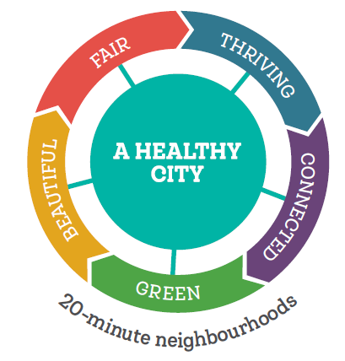
The MV2040 strategy will be delivered across 13 neighbourhoods, which will be planned so that people can access most of their everyday needs within a 20-minute walk, cycle or local public transport trip of their home.

The Social Determinants of Health (socio-ecological model of health)

Figure 2. The Social Determinants of Health
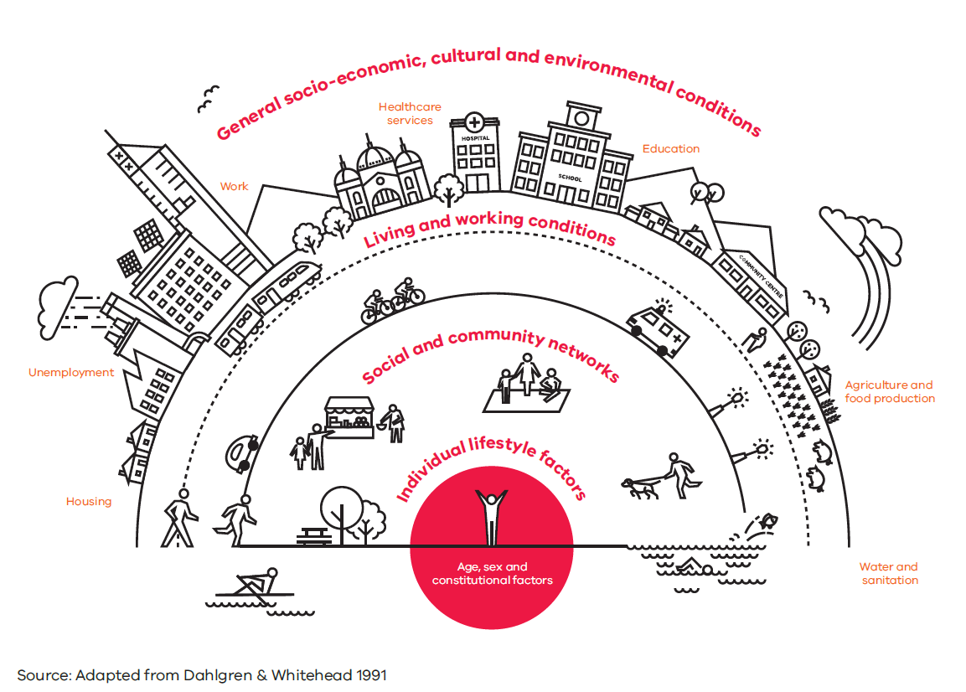
Health and wellbeing can be determined by many different factors. Economic, environmental, and social inequalities can determine people's risk of getting ill, their ability to prevent sickness, or their access to effective treatments. A widely used model that describes these determinants of health is the Dahlgren-Whitehead 'rainbow model' (Dahlgren-Whitehead, 1991). The model maps the relationship between the individual, social and community networks, living and working conditions, environmental conditions and health. Individuals are at the centre with set characteristics like sex, age, household composition and diversity. The next layer are individual factors that can promote or damage health – e.g. smoking. The third layer explores social and community networks. Structural factors like living and working conditions include individual socio-economic position, housing affordability and working conditions. Finally, the fourth level looks at the broad societal factors that protect or impair health. Examples here include social and environmental conditions and policies that help to create, maintain, or lessen socio-economic inequalities, thus health and wellbeing between groups.

COVID-19 Pandemic

Subsequent to the release of the Victorian Public Health and Wellbeing Plan 2019-2023, a major worldwide public health event, referred to as the COVID-19 pandemic, has had impacts on health and wellbeing. These health and wellbeing impacts are summarised at the end of each chapter.

COVID-19 in Moonee Valley
Since being reported in January 2020 to May 2021, the Moonee Valley community compared to other local government areas had the 9th highest number of COVID-19 cases (820 cases). Some areas of Moonee Valley such as Flemington, Travancore, Niddrie, Airport West and Ascot Vale, have experienced longer durations in lockdown compared to the rest of Metropolitan Melbourne.

Figure 3. Highest COVID-19 cases by LGA - as at 10 May 2021

Source: DHS, Victorian Coronavirus Data, 2021

As well as individual anxiety around COVID-19, restrictions on human contact and movement are public health controls have affected health and wellbeing. Restriction that have been implemented as measures to reduce the spread of COVID-19. The introduction of these restrictions is impacting on the economy (constraints on people’s ability to work and do business), education (students’ ability to attend schools/tertiary institutes), health (constraints on access to health services, manifestations of psychological distress, mental health issues, decreased physical activity etc.) and social (impacts of people being isolated). It is likely that health inequalities among impacted residents will increase.

Scope and data source

The aim of this document is to provide data about social determinants and the health status of residents in Moonee Vallee City Council. In interpreting the findings, caution is warranted due to some of the limitations of the data source, including underrepresentation of socio-economically disadvantaged and marginalised groups in the community (i.e. CALD, public housing tenants, people in very old age, and Aboriginal and Torres Strait Islander Peoples) and reliance on historical data (i.e. census data collected in 2016). Key resources used in the development of the Moonee Valley Health and Wellbeing Profile include:

- The Australian Bureau of Statistics, Census of Population and Housing, 2016 (all ages)
- The Victorian Population Health Survey, 2017 (adults aged 18 and older)
- Moonee Valley City Council Community Satisfaction Survey, 2021 (adults aged 18 and older)
- Turning Point – alcohol and other drugs statistical mapping 2010 – 2019 (all ages)
- Road accidents, VicRoads, 2019
- Australian Institute of Health and Welfare, Mortality, 2018
- Victorian Injury Surveillance Unit Monash University, 2018 (all ages)
- Crime Statistics Agency, Victoria, 2021
- Dental Health Services, Victoria, 2019 (Children aged 0-12)
- Australian National Healthy Survey, 2017 (all ages)

Moonee Valley target populations

The profile will highlight the impacts of the pandemic and will pay close attention to Moonee Valley target populations who are more vulnerable to experiencing health inequities including:

Aboriginal and Torres Strait Islander Peoples
Culturally and Linguistically Diverse (CALD)
People living on low and/or insufficient incomes
People experiencing homelessness
Children of all ages, with specific attention to the first thousand days (pregnancy to two years old) | 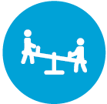
Young people
Older people | 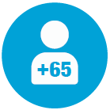
People with disability or mental illness
Carers
Lesbian, Gay, Bisexual, Trans and Gender Diverse, Intersex, Queer, Asexual and all other identities (LGBTIQA+)

Socially, locally and technologically isolated people | 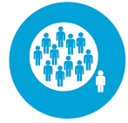
People at risk of exclusion due to reasons that may include family violence, pay inequities, unemployment gender stereotypes, being single parents, divorced or widowed

Moonee Valley location

The Wurundjeri Woi-wurrung people are the Traditional Custodians of Moonee Valley and have over 40,000 years of connection to the area. For thousands of years they have cared for the land and waterways and this area known as the Kulin Nation has ongoing cultural and spiritual significance.

The City of Moonee Valley is located in the inner metropolitan suburbs of Melbourne, between 4 – 13 kilometres from the Melbourne Central Business District (CBD). The city covers 43 square kilometres and encompasses the suburbs of Aberfeldie, Airport West, Ascot Vale, Avondale Heights, Essendon, Essendon North, Essendon West, Flemington, Keilor East, Moonee Ponds, Niddrie, Strathmore, Strathmore Heights, Travancore, and Essendon Fields. Moonee Valley is an established residential municipality. Complementing its residential areas is a mix of retail strips and centres, combined with offices, some industrial areas and Essendon Airport (Replan, 2021).

Figure 4: Locality Moonee Valley LGA
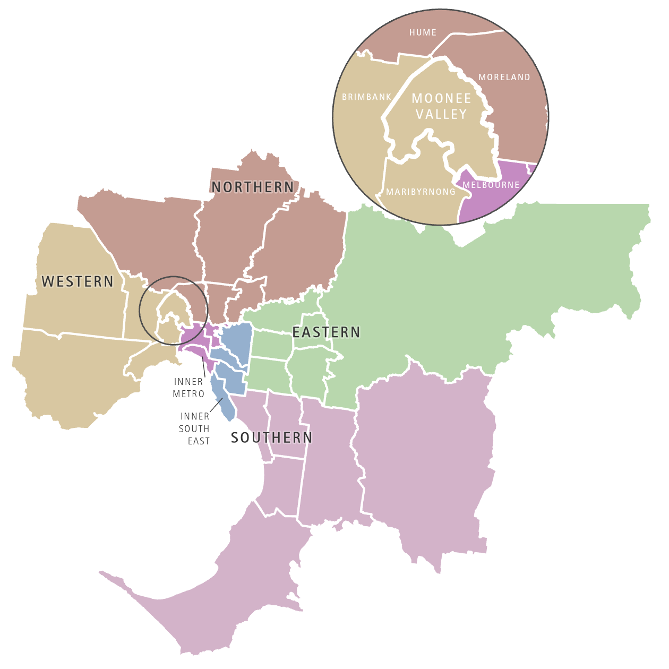

Council is moving to a neighbourhood planning approach guided by Plan Melbourne 2017-2050. Plan Melbourne 2017-2050, focuses on improving Melbourne’s health and liveability through the creation of 20-minute neighbourhood. In line with this plan, Moonee Valley City Council is focussing on 13 neighbourhood locations. Each of the 13 neighbourhoods has a distinctive character and identity, with individual challenges and opportunities for improving health and wellbeing. The benefit of neighbourhood planning is to identify local priorities and tailor responses. The boundaries of the Moonee Valley’s neighbourhood locations differ slightly to suburb, postcode and Australian census district boundaries. Some of the data in this Health Profile will relate to suburb, and others to neighbourhood. This will be clearly stated to avoid confusion.
Figure 5: Suburbs of Moonee Valley LGA
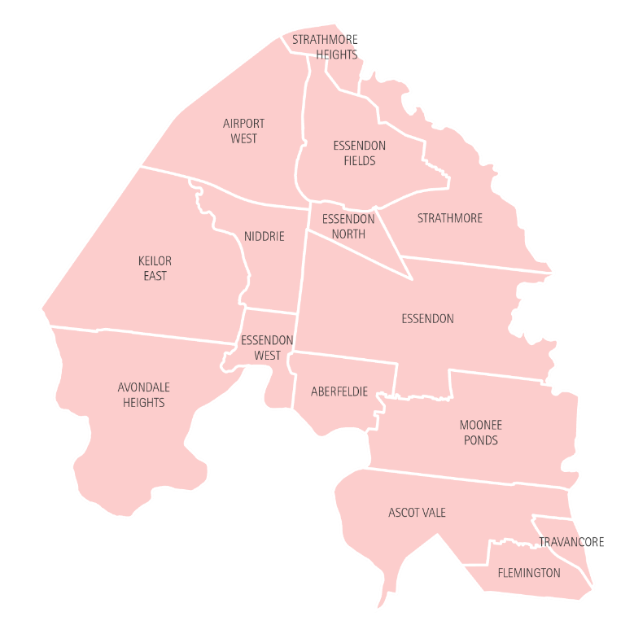
Figure 6: Neighbourhood catchments of Moonee Valley LGA
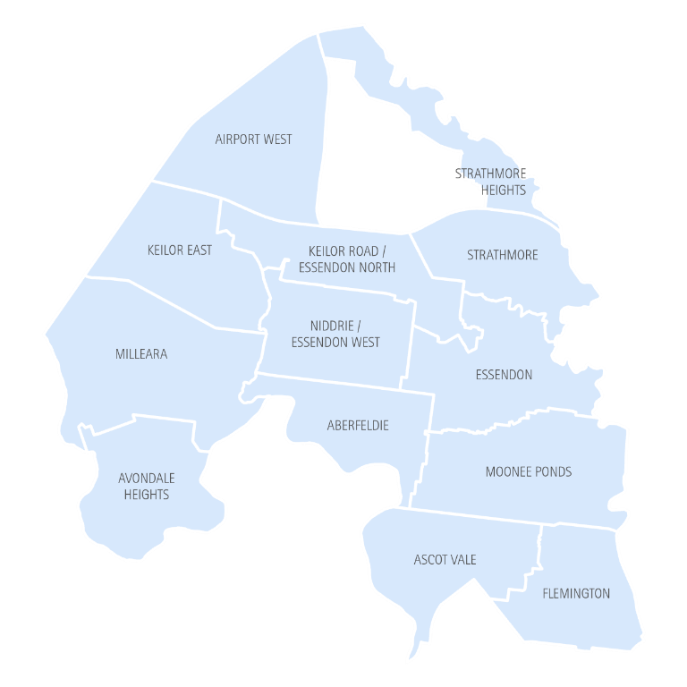

Our people

Key points:
- Moonee Valley City Council has an ageing population. The greatest projected growth is among the 80 + age group (up 71.3 per cent from 6,905 people in 2016 to 11,951 people in 2041 ) and are most likely to live in the Keilor East and Milleara neighbourhoods
- The birth rate is falling
- The municipality enjoys a diverse population, with almost a third of residents speaking non-English languages at home. Italian and Greek spoken in North/Eastern parts of Municipality; Arabic and Cantonese spoken in South East (i.e. Flemington)
- 0.3 per cent of Moonee Valley residents (430 people) identify as Aboriginal and/or Torres Strait Islander
- Avondale Heights has the largest number of Asylum Seekers
- The most common household type is couples with children, which account for approximately 31 per cent of households
- Population forecasts suggest that between 2016 and 2041 the number of lone person households will increase by 57 per cent, the greatest level of growth of any household type across the municipality
- Approximately 5 per cent of community dwelling residents live with a disability, with approximately 45 per cent of people over the age of 65 living with disability. The disability rate is likely to increase in-line with an ageing population
- Approximately 8% of adults identify as LGBTIQA+

Age and sex profile

On 30 June 2019 there were 130,294 people calling Moonee Valley City Council home and the median age was 37.8. Sixteen and a half per cent were aged less than 15, and 7.9 per cent were aged over 75. Moonee Valley’s residents are on average older than the population of Greater Melbourne. Figure 7 below highlights there are smaller proportions of younger people and a higher proportion of older people in Moonee Valley City Council compared to those living in Greater Melbourne.

Figure 7. Moonee Valley's Population Compared to Greater Melbourne by Age

Source: ABS, Regional Population by Age, 2019

Demographic change
The population of the City of Moonee Valley is forecast to increase from approximately 133,250 residents in 2021, to around 166,000 in 2041. This is an increase of approximately 25 per cent over 20 years.

Figure 8. Moonee Valley City Council Forecast Population, 2016-2041

Source: REMPLAN, Moonee Valley Population Forecasts, 2021

It is projected that there will be an increase in the population of all age groups living in Moonee Valley City Council. Similar to Australian and Victorian population trends, Moonee Valley City Council has an ageing population. The greatest projected change is among the 80 + age group with a forecast growth of 71.3 per cent (from 6,905 people in 2016 to 11,951 people in 2041 ). People aged 65-79 have the second leading forecast growth of 41.5 per cent (from 14,908 people in 2016 to 21,099 in 2041). The sex distribution shows that in 2021 there are more women than men (men = 63,442 and women 66,852). Among children and youth there are slightly more men. There are approximately equal proportions of men and women among adults (aged 18 to 60). However, from the ages of 60 and over there are more women. This is especially evident in the 85+ age group where there were 37 per cent men and 63 per cent women.

Figure 9. Moonee Valley Forecast Population by age and sex, 2021 and 2041
Source: REMPLAN, Moonee Valley Population Forecasts, 2021

It is predicted that by 2041, by residential area, the highest proportions of those aged 65 years and over would live in Keilor East (28.4 per cent) and in Milleara (27.7 per cent). Moonee Ponds and Flemington are likely to have the highest proportions of young people aged under 25.

Figure 10. Estimated population in 2041 by age and location

Source: REMPLAN, Moonee Valley Population Forecasts, 2021

Births
The birth rates in Moonee Valley City Council have been falling since 2015. Data from Moonee Valley’s Maternal Child and Health (MCH) team show that there were 1,487 births in the municipality in the 2019-20 financial year. This is higher than in 2018-19, but lower than in earlier years. The highest number of births are recorded at Strathmore and Milleara.

Table 3. Annual number of births by Maternal Child Health Centre in Moonee Valley

MCH | 2015-16 | 2016-17 | 2017-18 | 2018-19 | 2019-20
Aberfeldie | 96 | 111 | 83 | 91 | 99
Airport West | 116 | 116 | 132 | 122 | 130
Ascot Vale | 154 | 161 | 176 | 161 | 150
Avondale Heights | 147 | 124 | 124 | 125 | 134
Hopetoun | 167 | 167 | 177 | 162 | 152
Milleara | 254 | 227 | 238 | 222 | 230
Montgomery Park | 160 | 131 | 111 | 117 | 129
Shuter Street | 117 | 135 | 119 | 118 | 139
Strathmore | 253 | 261 | 281 | 234 | 233
Wingate | 95 | 104 | 102 | 98 | 91
Total | 1559 | 1537 | 1543 | 1450 | 1487
Source: Moonee Valley City Council, 2020

Household composition

Moonee Valley City Council is home to many types of families. Data from the 2016 Census shows that the most common household type is couples with children, who account for approximately 31 per cent of all households. Lone person households make up about 25 per cent of households, which was more than was recorded in Greater Melbourne (i.e. 22%).

Figure 11. Household composition, Moonee Valley compared to Greater Melbourne as at 2016 Census

Source: ABS, Census 2016

One parent families in Moonee Valley are predominately headed by females (82.3%), compared to males (17.7%). Women’s Health West report that single mothers remain one of the most economically disadvantaged groups in Australia, due to the growing gender pay gap, high representation in casual and part time work, and time out of the work force due to child bearing (Women’s Health West, 2021).

Living alone

In 2016, the areas with the highest proportion of lone person households were Flemington (33.3 per cent), Keilor Road/Essendon North (31.1 per cent) and Moonee Ponds (31.0%).

Figure 12. Lone person households in Moonee Valley by neighbourhood, % of total households

Source: ABS, Census data 2016, compiled by REMPLAN

Population forecasts suggest that between 2016 and 2041 the number of lone person households in Moonee Valley will increase by 57 per cent, the greatest level of growth of any household type across the municipality. There’s also predicted decrease of households comprising of couples with children (32 per cent down to 30 per cent (REMPLAN, 2021).

Diversity of Moonee Valley
Moonee Valley City Council is home to people from diverse genders, abilities, and cultural and language backgrounds.

Aboriginal and Torres Strait Islander peoples
Council recognises the significant and important role of Aboriginal and Torres Strait Islander peoples and their culture. At the 2016 Census, there were 430 Moonee Valley City Council residents who identified as Aboriginal and/or Torres Strait Islander people, which has increased from previous years. This was equal to 0.4 per cent of the Moonee Valley population at the time and is similar to neighbouring municipalities (0.5 per cent in both Moreland and in Maribyrnong). Census data also shows a lower median age (28 years) for the indigenous population compared to the non-Indigenous population (38 years).

Figure 13. Moonee Valley Aboriginal and/or Torres Strait Islander population 2001-2016

Source: ABS, Census, 2016

LGBTIQA+
With the absence of Census data on the LGBTIQA+ population, reliable and comprehensive national data is limited. From the 2017 population health survey, the Victorian estimate of adults identifying as LGBTIQA+ was 5.7 per cent, and for Moonee Valley it was higher at 8 per cent. Although people identifying as LGBTIQA+ lead healthy and connected lives, discrimination and isolation due to their gender identity, can contribute to poor health and wellbeing outcomes, especially poor mental health. These poorer health outcomes can be attributed to the impact of ‘minority stress’ - the chronic stressors that LGBTIQ+ people are uniquely exposed because of sexuality, gender and bodily diversity being socially stigmatised. This includes discrimination, social exclusion, harassment and physical violence (LGBTIQ+ Health Australia, 2021).

People living with a disability
The Australian Bureau of Statistics defines disability as “any limitation, restriction or impairment which restricts everyday activities and has lasted, or is likely to last, for at least six months” (ABS, 2018). Looking at Australian trends in 2018, the ABS reports that among people living in households:
- The prevalence of disability increased with age - one in nine (11.6 per cent) people aged 0-64 years and one in two (49.6 per cent) people aged 65 years and over had disability.
- Disability prevalence was similar for males (17.6 per cent) and females (17.8 per cent).
- 5.7 per cent of all Australians had a profound or severe disability.
- Almost one-quarter (23.2 per cent) of all people with disability reported a mental or behavioural disorder as their main condition, up from 21.5 per cent in 2015.
Data for Moonee Valley City Council indicates that at least 18,325 people are living with a disability, and there are more women living with a disability than men (Men: 8,684; Women: 9,641). People living with disability in Moonee Valley are more likely to be aged over 65, and the proportion of men living with a disability over the age of 65 is 45.1 per cent and for women it is 44..8 per cent.

Figure 14. Proportion of Moonee Valley population living in households with a disability, by sex

Source: ABS, 2018a

The Australian Bureau of Statistics Core Activity Need for Assistance indicator measures the number of people with a profound or severe disability. This includes people needing help in the three core activity areas of self-care, mobility and communication, as a result of a long-term health condition (more than 6 months), disability, or old age. Approximately five per cent of Moonee Valley residents have a core need for assistance with activities for daily living, which is slightly less than the national average (5.8 per cent). Older Moonee Valley residents are more likely to require assistance for daily living, compared to younger ages. For those aged 85 years and over, this equates to 56 per cent of women and 47 per cent of men.

Figure 15. Proportion of the Moonee Valley City Council population with a need for assistance, by age and sex

Source: ABS, Census 2016

Carers
Carers can face a number of challenges. Challenges include financial hardship, social isolation, relationship strain, as well as missing out on work, career and education opportunities (Sarris et al, 2020). Women are two and a half times more likely to be a primary carer of someone with disability than men. Data from the 2016 Census indicates 12 per cent of the Australian population aged 15 years and over provided unpaid assistance to a person with disability, long term illness or old age. Those between 50 and 64 years were most likely to be carers.

Across Victoria nearly 10% of people report unpaid caring responsibilities to people living with long term health conditions or disabilities. Women in Moonee Valley are more likely to provide unpaid assistance to people living with disabilities (Female 11.8%; Male 8.0%).

Table 4. Unpaid assistance to a person with a disability
 | Moonee Valley |  | Victorian average
 | Female | Male | Female | Male | All
2016 | 11.8% | 8.0% | 11.9% | 8.0% | 9.9%
Source: ABS census citied in VWH Atlas Fact Sheet

People from CALD and non-English speaking backgrounds
The City of Moonee Valley has a culturally diverse community profile with 32,268 people arriving from overseas in 2016; 6,368 (19.7 per cent) of whom having arrived in the previous five years. In 2016 just over a quarter (27.6 per cent) of the community in the City of Moonee Valley were born overseas (ABS, 2016). The most common languages spoken at home (other than English) by residents of the City of Moonee Valley are Italian, Greek, Vietnamese, Mandarin, Cantonese and Arabic.

Table 5. Top 7 Languages spoken at home other than English in MVCC

Language spoken at home | Residents | Percentage
English | 75,216 | 64.5
Italian | 7,916 | 6.8
Greek | 3,631 | 3.1
Vietnamese | 2,732 | 2.3
Mandarin | 2,078 | 1.8
Cantonese | 1,819 | 1.6
Arabic | 1,723 | 1.5
Source: ABS, Census 2016
Figure 16 below shows that Italian and Greek are more likely to be spoken in the northern areas of the municipality, whereas Cantonese and Arabic are more likely to be spoken in the south east.

Figure 16. Top languages spoken other than English based on ABS Statistical Area Level 1 (SA1) 2016

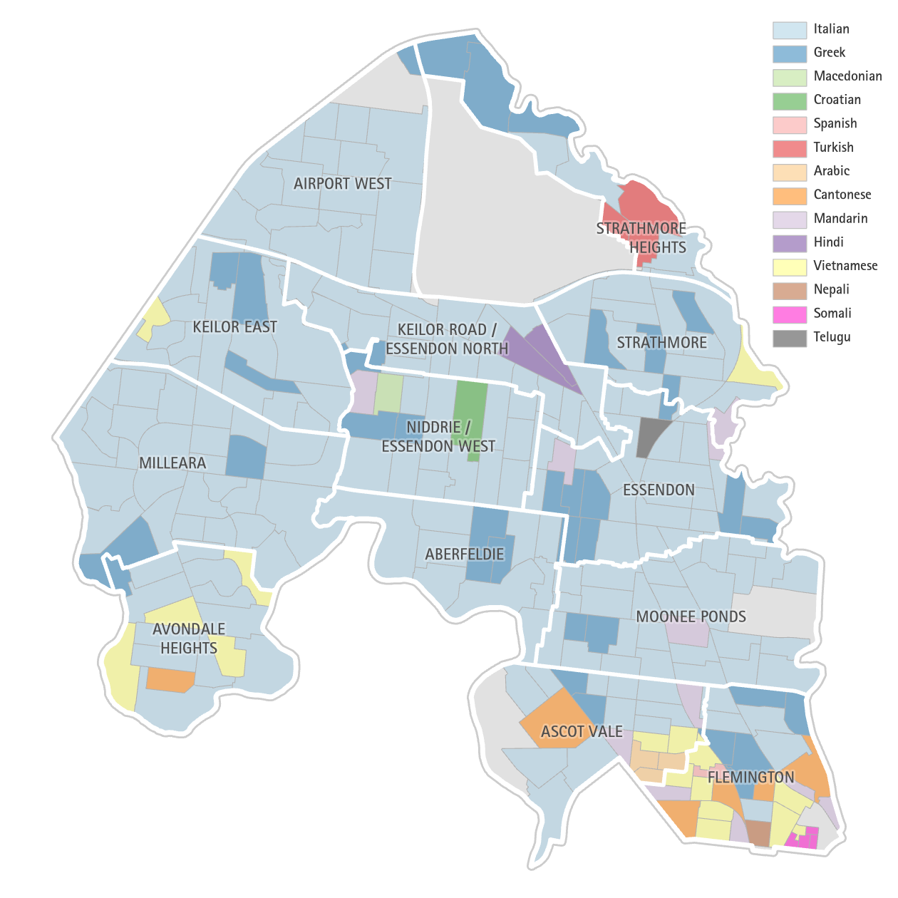

Census data shows that for Moonee Valley residents, those who spoke Hindi, Maltese, and Turkish were the most likely to also speak English ‘very well’. People who spoke Cantonese and Vietnamese had the highest proportion of people who reported speaking English ‘not well’ and ‘not at all’.

Table 6. Self-assessed English proficiency in Moonee Valley By language spoken at home (top 12 languages other than English)

Source: ABS, Census 2016

Refugees and asylum seekers
Most refugees and asylum seekers arrive in Australia having experienced poverty, torture and trauma (Camacho, 1999). They may have spent long periods of time in refugee camps and be unfamiliar with urban environments and the way of life in Australia (Federation of Ethnic Communities’ Councils of Australia, 2015). Migrants and refugees face several social, economic and cultural issues, including language barriers, compromised mental health and wellbeing, lack of work experience and recognised qualifications, racism and discrimination, underemployment, and difficulties accessing health and support services.

In 2018 there were 1,439 new arrivals from overseas settling in the City of Moonee Valley, 21 of whom were humanitarian (2.2 per cent), 540 of whom were in the family stream (37.5 per cent) and 868 of whom were in the skilled stream(60.3 per cent) (DoHA, 2019). In Australia in 2018, the largest increases in refugee populations were from Syria (343,850), Democratic Republic of Congo (99,500), Afghanistan (57,230), Central African Republic (45,350) and Nigeria (37,850) (Refugee Council Australia, 2020). The proportion of humanitarian arrivals in the City of Moonee Valley was lower than the average for Victoria (2.2 per cent and 5.2 per cent respectively).

Data from June 2020 from the Australian Department of Human Affairs (DoHA) shows that there were 100 asylum seekers living in postcode areas covered by the City of Moonee Valley. This is a decrease on the number from June 2019 (117). The June 2020 data shows that asylum seekers were located in:
- 34 in the 3034 postcode area (Avondale Heights). This is the 37th highest for postcode areas in Victoria.
- 15 in the 3032 postcode area (Ascot Vale and Travancore, but also Maribyrnong)
- 21 in the 3033 postcode area (Keilor East – most of the residential parts are within Moonee Valley)
- 20 in the 3042 postcode area (Airport West and Niddrie, but also Keilor Park)
- 10 in the 3040 postcode area (Essendon, Niddrie and Aberfeldie)

International students
In 2016, the number of international students attending TAFE and University was 1713. In total there were 9,167 TAFE and University students living in Moonee Valley in 2016, meaning international students accounted for about 19% of all post-secondary education students living in the municipality.

Figure 17. Number of TAFE and university students living in Moonee Valley at 2016 Census

Source: ABS, Census 2016

Impact of COVID-19 for our diverse and target populations
The COVID-19 crisis has amplified some of the existing disparities in health and wellbeing for CALD communities, LGBTIQA+ communities, refugee and asylum seekers, international students and people living with disabilities due to challenges accessing support, disruption in trusted community networks, and the prevailing lack of culturally responsive mental health services. Carers are also already more isolated than the general population and may be further exacerbated during the pandemic. There is potentially increased anxiety as they maybe caring for someone at-risk of contracting the virus.

Individual behavioural factors influencing health and wellbeing

Key points:
- Alcohol use and drug taking among adults is higher compared to the Victorian average and the Western Melbourne area
- Males were more likely to be hospitalised compared to females due to their drug and alcohol behaviour
- Tobacco use is slightly lower than the Victorian average, and on par with the rest of Western Melbourne area
- In a usual year, almost $80 million is lost through pokies in the City of Moonee Valley
- Physical activity rates for adults are higher compared to Metropolitan Melbourne
- Moonee Valley City Council residents had healthier eating behaviour, i.e. consumption of fruit and vegetables compared to other metropolitan municipalities however there is room for improvement as only 3.2 per cent of Moonee Valley City Council adults met the healthy eating guidelines.
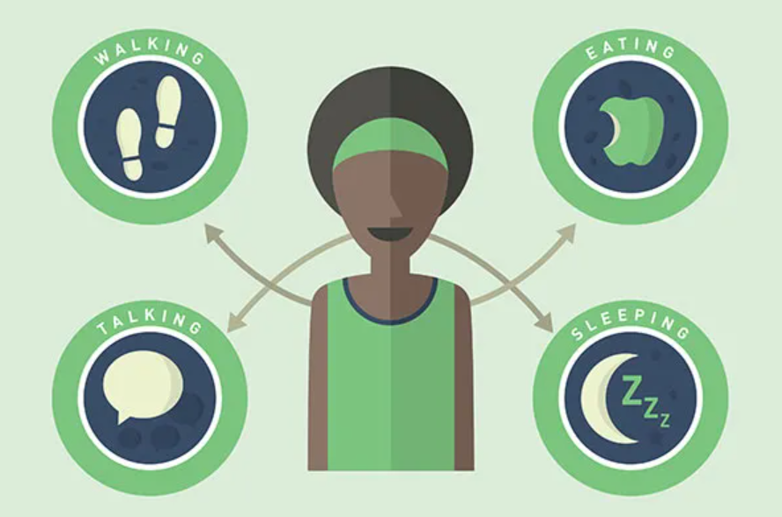
Many of our behaviours influence our health and wellbeing. Health promotion efforts aim to change behaviours and thereby prevent avoidable poor health, illness, injury and death. The Victorian Government includes reducing tobacco-related harm, reducing harmful alcohol and drug use, and increasing active living, among their top priorities (Department of Health and Human Services, 2019).

Smoking

Tobacco is a highly addictive stimulant that contains nicotine, a substance that is found in cigarettes, cigars, pipes (Department of Health and Human Services, 2019) and vaping devices. Tobacco smoking is the leading preventable cause of death and disease in Australia and is a risk factor for many chronic conditions such as respiratory diseases, cancer and cardiovascular disease. Smoking not only affects the health of the individual, but also impacts the health of those who live or are in an environment where there is on-going exposure to tobacco smoke. Second-hand smoke is a term that describes the smoke that has come from a burning tobacco product that has been inhaled by someone other than the active smoker. Children who live with parents that are regular smokers and those in certain occupations are some of those who experience a higher rate of second-hand smoking or passive smoking (Better Health Channel, 2019).

Data from the Victorian Population Health Survey 2017 shows that among adults aged 18 and older, smoking levels in Moonee Valley are similar to those in Western Melbourne and Victoria. About 15 per cent of Moonee Valley adults are current smokers. Smoking levels are higher for men (17 per cent), than for women (14 per cent). Approximately sixty percent of adults in Moonee Valley said they were non-smokers.

Figure 18. Smoking status

Source: DHHS, Victorian Population Health Survey, 2017, adults aged 18 and older

Alcohol and other drugs

Alcohol is a drug that alters the way people think, feel and behave, and is both addictive and a depressant. Long term and heavy alcohol drinkers are more likely to develop mental health conditions, diabetes, weight gain, cancers (stomach, bowel, liver, etc.), heart conditions, have liver failure, or sustain an injury while under the influence. Unborn babies are also at risk of health conditions if their mother consumes alcohol whilst pregnant. Consumption of alcohol can also impact family relationships, exacerbate domestic violence as well as create financial and social stress (Department of Health, 2020).

Data from the Victorian Population Health Survey 2017 shows that Moonee Valley residents (aged over 18) are more likely to have increased levels drinking - referred to as alcohol related harm - when compared to Western Melbourne and the Victorian average. This is true for both lifetime risk of alcohol related harm, as well as for alcohol related harm from a single occasion of drinking.

Figure 19. Moonee Valley alcohol consumption at risky levels, compared to Victoria and Western Melbourne area

Source: DHHS, Victorian Population Health Survey, 2017, adults aged over 18.

Factors such as how easy it is to obtain alcohol, affordability, social norms, and marketing are associated with the prevalence of alcohol-related harms. Prevention efforts need to take into consideration these multiple factors (Roche et al, 2015).

Access to alcohol outlets:
Both on-licence (such as restaurants and pubs) and off-licence (such as bottle shops) alcohol outlets are generally located in activity centres in Moonee Valley. These are most concentrated in the east of the municipality, which also has a higher level of area advantage (indicated by the yellow shading in Figure 20). There are few alcohol outlets in the western part of the municipality.

Figure 20. Alcohol outlets operating in the Moonee Valley LGA by neighbourhood level disadvantage

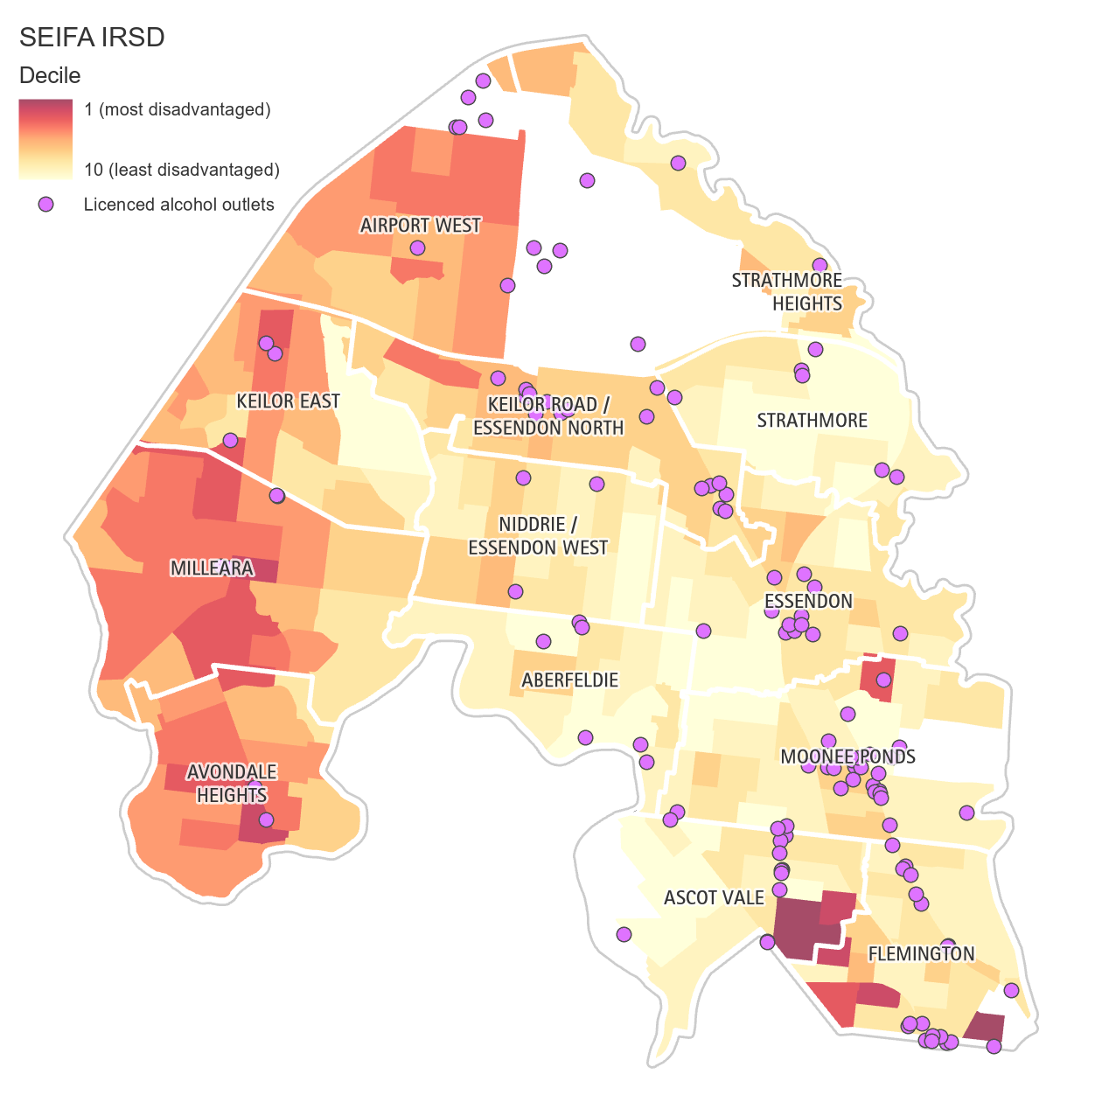

Data from Turning Point shows that there were over 600 alcohol related hospital admissions for Moonee Valley residents (all ages) in 2018-19 . The majority of these were men, who were admitted at twice the rate of women. For men (but not for women) there has been an increasing trend of alcohol related hospital admissions from 2010 to 2019.

Figure 21. Alcohol hospitalisations by sex, Moonee Valley

Source: Turning Point, AODStats, 2020

Moonee Valley had a higher rate of alcohol related hospitalisations per 10,000 population than many other local government areas in the North West region, although it is not the highest, as indicated by the faint grey lines in the figure below.

Figure 22. Alcohol related hospitalisations per 10,000 people, Moonee Valley compared to other LGAs in North-West Health Region

Source: Turning Point, AODStats, 2020

Drugs
Data from Turning Point shows that there were over 300 illicit drugs related hospital admissions for Moonee Valley residents in 2018-19. Males were 1.6 times more likely to be admitted to hospital than females. Over the period 2010 to 2019 there appeared to be an increase for both male and female illicit drug related hospital admissions.

Figure 23 Illicit drug related hospitalisations by sex, Moonee Valley

Source: Turning Point, AODStats, 2020

Moonee Valley has a higher rate of illicit drugs related hospitalisations than many other local government areas in the North West region. It can also be seen that illicit drug related hospitalisations for both men and women have increased steadily since 2012, more than doubling for men, and almost doubling for women.

Figure 24. Illicit drug related hospitalisations per 10,000 people, Moonee Valley compared to other LGAs in North-West Health Region

Source: Turning Point, AODStats, 2020

Gambling
Gambling harm is any negative consequence that comes from gambling and includes negative consequences such as; financial, relationship, health, emotional, work and cultural. Gambling harm can result from a person’s own gambling or someone else’s and leads to poorer health and wellbeing of the individual and family (Victorian Responsible Gambling Foundation, 2020).

Data from the Victorian Responsible Gambling Foundation shows that over $77.6 million was spent on pokies in Moonee Valley in 2018-19, equating to $212,742 per day across 11 venues with pokies.

Figure 25. Moonee Valley gambling summary
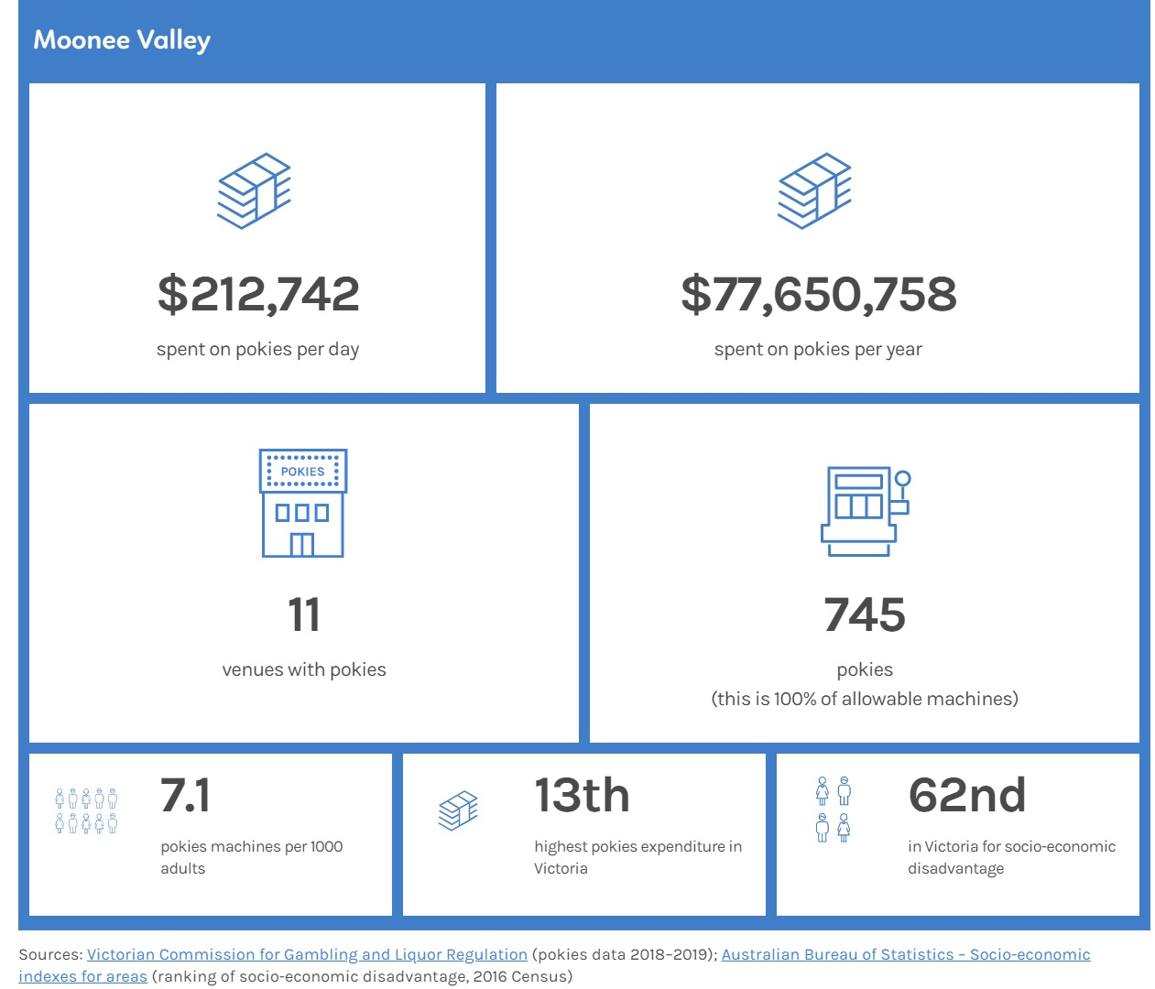

In a usual year, almost $80 million is lost through pokies in the City of Moonee Valley. However, this figure was $58 million in the 2019-20 financial year as pokies venues have been closed temporarily in lockdowns.

Figure 26. Expenditure on electronic gaming machines (pokies) in Moonee Valley

Source: Victorian Commission for Gambling and Liquor Regulation, 2020

When looking at the distribution of Electronic Gaming Machines (EGMs) in Moonee Valley, they are concentrated in the east of the municipality (mostly in Moonee Ponds and Essendon) - areas of higher neighbourhood socio-economic advantage (i.e. IRSD).

Figure 27. Number of Electronic Gaming Machines and neighbourhood-level socioeconomic disadvantage
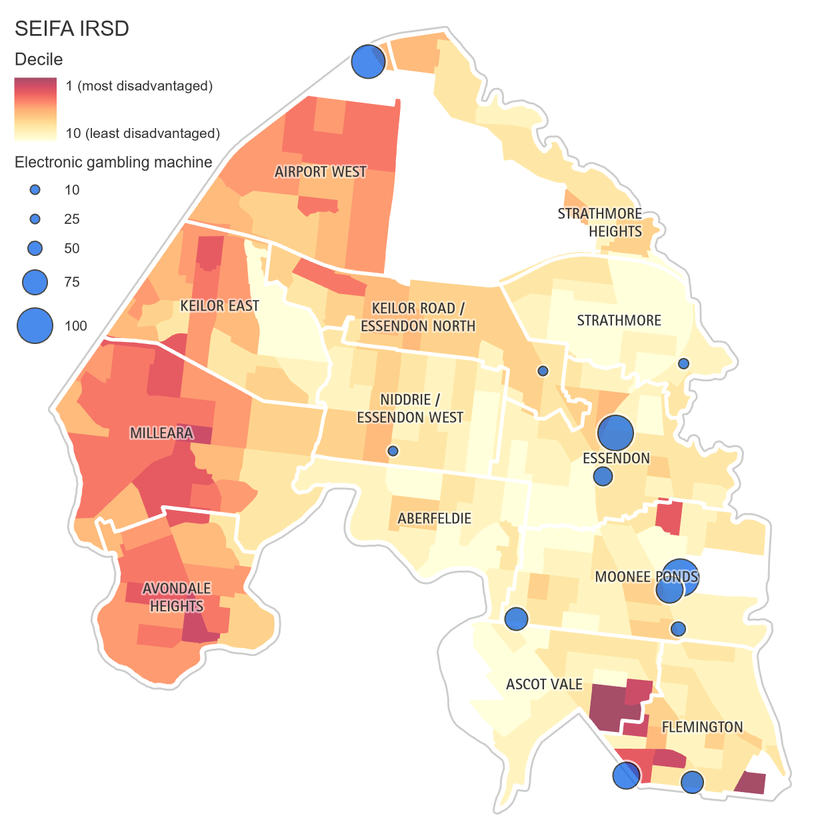

Physical activity

Regular physical activity is important for optimal health and wellbeing, reducing the risk of many health conditions such as cardiovascular disease and type 2 diabetes. Physical activity enables people to recover from injuries and illnesses, and has been found to address mental health issues such as depression (Better Health Channel, 2018). Increasing levels of physical activity among older people can prevent falls and improve cognitive function.

Data from the Victorian Population Health Survey 2017 shows that approximately 58 per cent of Moonee Valley residents complied with physical activity recommendations, compared to 48.5 per cent in the Western Melbourne Area.

Figure 28. Met physical activity guideline in Moonee Valley compared to Victoria and Western Melbourne Area

Source: DHHS, Victorian Population Health Survey, 2017

Healthy diet
Healthy eating is a key determinant of health and wellbeing, helping to prevent and manage health risk factors such as overweight and obesity, high blood pressure and high cholesterol. Daily intake of fruit and vegetables is used as a proxy measure of the quality of a person's diet in Australia and internationally. Based on self-reported data from the Australian Bureau of Statistics (ABS) 2017–18 National Health Survey (NHS), Australians aged 18 or over in the lowest socioeconomic areas were less likely to meet the fruit and vegetable guidelines than those in the highest socioeconomic areas (AIHW, 2019).Data from the Victorian Population Health Survey shows 3.2 per cent of Moonee Valley residents compared to 2.9 per cent for Western Melbourne area met the fruit and vegetable consumption guidelines of consuming two serves of fruit and five serves of vegetables a day in 2017.

Figure 29. Consumed two serves of fruit and five serves of vegetables per day

Source: DHHS, Victorian Population Health Survey, 2017

Food insecurity
In order for people to engage in healthy eating behaviours, food needs to be available, nutritious, culturally appropriate and affordable (VicHealth, 2012). Food insecurity occurs when people lack access to enough food for an active and healthy life due to the inability to purchase, store and cook food, and/or when their neighbourhoods do not provide sufficient access to healthy food outlets. Food insecurity can affect academic achievement in children, and is a contributing factor to childhood overweight and obesity. Families experiencing food insecurity may need to purchase cheaper food which is energy dense but nutrient poor (Rosier, 2011). In 2014, survey results from the VicHealth indicators survey indicated a lower proportion of people in the City of Moonee Valley were experiencing food insecurity (2.5 per cent) compared with the average Victorian measure (4.6 per cent).

Access to fresh food provides residents with the opportunity to purchase nutritional foods which support healthy eating behaviours and lifestyles. Supermarkets are a common source of fresh healthy foods, but additionally, local retail outlets such as fruit and vegetable retailers (greengrocers), farmers markets and community gardens can also provide residents with the opportunity to purchase nutritional foods. Conversely, fast-food outlets may contribute to unhealthy food choices.

Impact of COVID-19 on individual behavioural factors

Smoking: There was a mix of both positive and negative results for smoking rates during the pandemic. Some Victorians attempted to quit because they believed smoking would increase the severity of COVID-19 if they were to contract the virus and many wanted to save money due to job loss or financial uncertainty (VicHealth, 2020).
Alcohol consumption: With pubs and bars intermittently closed due to COVID-19 restrictions, more drinking may be taking place at home. Research from the Foundation for Alcohol Research and Education (FARE) suggests that 20 per cent of Australians purchased more alcohol, with 70 per cent drinking more alcohol than normal. Around one-third of these were concerned with their drinking and more than a quarter said they used alcohol to cope with anxiety and stress (FARE, 2020). It is likely that there would be similar levels of drinking among Moonee Valley residents during COVID-19.
Drugs: The trends and patterns of illicit drug use have changed since the pandemic lockdowns began. Rates of usage for some illicit drugs increased (i.e. cannabis increased usage 57per cent) for prior users however, rates of usage for some other illicit drugs also decreased (i.e. cocaine, MDMA and ketamine) (Australian Institute of Health and Welfare, 2020).
Gambling: The closure of gambling and pokies venues had an immediate benefit for some who gamble, particularly those who are not online gamblers. However, there was an increase in those who signed up to an online betting platform during the pandemic and a rise was seen in the amount of people who started to gamble online (Australian Gambling Research Centre, 2020).
Physical activity: The VicHealth Coronavirus Impact Survey reported that most people were able to continue being active but there were some limiting factors (VicHealth, 2020). The pandemic reduced access to sport and recreational facilities as well as limited participation in group settings. During lockdowns people valued living in areas with good access to open space and infrastructure and it is plausible that people living in these area were able to be more active than those living in areas with less access to open space and infrastructure.
Healthy eating: The VicHealth Coronavirus Impact Survey reported an increase in people eating more vegetables because they were cooking more at home (VicHealth, 2020). There was a rise in food insecurity and is likely to remain an issue during the COVID-19 pandemic (VicHealth 2020). Throughout metropolitan Melbourne food relief was an issue for international students, older people and the CALD community during various lockdowns (i.e. Flemington public housing estate), many of whom had specific requests for culturally appropriate food.

Individual living and working conditions

Key points:
- Moonee Valley City Council is more socio-economically advantaged compared to other metropolitan municipalities.
- The unemployment rate is highest in Flemington and Ascot Vale, and lowest in Strathmore.
- Moonee Valley City Council has a high proportion of social housing, with almost 9 per cent of dwellings as social housing stock
- There is limited availability of affordable housing and rental properties.
- Women are less likely to be employed or earn high salaries compared to men.
- In June 2019, there were 1,168 residential aged care places, which is higher than some other metropolitan council areas.

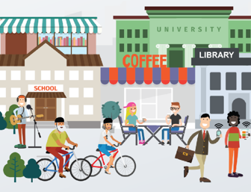
Living and working conditions are closely tied to health. Factors such as income, education, conditions of employment, strengthen or undermine the health of individuals and communities (AIHW, 2016).

The social gradient in health is a term used to describe the phenomenon whereby people who are less advantaged in terms of socioeconomic position have worse health (and die at younger ages) than those who are more advantaged. The gradient means that for every incremental increase in socioeconomic position, there is an increase in health and wellbeing. Socioeconomic disadvantage is the greatest cause of health inequality in Victoria and while the greatest relative difference in health status for population groups is between Aboriginal Victorians and non- Aboriginal Victorians, there are also health inequalities between other population groups (DHHS, 2015).

Education
Education achievement is a common measure of socioeconomic position. Those who receive a quality education and obtain? qualifications are more likely to attain higher paying and secure jobs, raising their socioeconomic status and thus, produce better health outcomes.

Data from the 2016 Census shows that there are higher levels of educational attainment in Moonee Valley when compared to Greater Melbourne. About 31 per cent of adults in Moonee Valley have a bachelor degree or higher, compared to 27.5 per cent for Greater Melbourne. Approximately 20% of Moonee Valley adults highest level of education was below Year 12.

Figure 30. Highest level of educational attainment, Moonee Valley compared to Greater Melbourne

Source: ABS, Census 2016

Employment

Employment is another common measure of socioeconomic position. Employment provides income, sense of purpose and can reduce psychological stress. Adults who are unemployed have a higher risk of death, illness, and disability compared to people who are employed. In addition, unemployment can cause psychological challenges, impacting negatively on mental health (AIHW, 2016).

Data from the 2016 Census shows that there are similar employment levels in Moonee Valley when compared to Greater Melbourne. About 60 per cent of those in the labour force work full time, while about 30 per cent work part time. The proportion of Moonee Valley adults in the work force has remained largely unchanged according to previous census years (i.e. Full time = 62per cent in 2006, 61per cent in 2011; Part Time = 27per cent in 2006, 28.7per cent in 2011)

Figure 31. Employment type for those in the labour force, Moonee Valley compared to Greater Melbourne

Source: ABS, Census 2016

People experiencing unemployment
The unemployment rate in the City of Moonee Valley has generally been lower than that of Greater Melbourne since 2012. It should be noted that the dataset runs to March 2020 and thus does not reflect the full impacts of the COVID-19 pandemic.

Figure 32. Quarterly unemployment rates, Moonee Valley compared to Greater Melbourne, Dec 2010 - Mar 2020

Source: Small Area Labour Markets, Department of Education, Skills and Employment, 2020

Gender differences in employment and income
Data from the 2016 Census shows that females in Moonee Valley do more unpaid work (housework, carer responsibilities and volunteer work), and have lower incomes and less likely to participate in the labour force, than their male counterparts.
Figure 33. Moonee Valley gender differences in employment and income

Note: The labour force participation rate is the proportion of the population aged 15 years and over that are in the labour force (i.e. either in work, or looking for work).
Source: ABS, Census 2016

Housing

Having access to safe, secure and affordable housing is crucial for health and wellbeing and an important precondition for participation in employment, education and the community (AIHW, 2016).

Home ownership
In 2016, about two-thirds of dwellings were owned in Moonee Valley. Of these, 35 per cent were owned outright, while 29 per cent were owned with a mortgage. 32.5 per cent of homes were rented (of the rented dwellings, about 14 per cent were social housing). There is a higher proportion of those who own their home outright in Moonee Valley compared to Greater Melbourne. Census data also shows that Aboriginal and Torres Strait Islander people are almost twice as likely to rent compared to the non-Indigenous population (59 per cent compared to 32 per cent).

Figure 34. Housing Tenure in Moonee Valley compared to Greater Melbourne

Source: ABS, Census 2016

Cost of housing
There are several suburbs within Moonee Valley where houses cost approximately double the Melbourne average. In 2020-21, the highest median house sale price in the municipality was in Strathmore ($1.425 million) and the lowest in Airport West ($765,000). For rentals, the highest median rent per week was in Ascot Vale ($578 ) compared to the lowest in Avondale Heights ( $435 per week).

Table 5: Cost of housing and renting summary for Moonee Valley
Housing and rental prices
- Municipal median house price = $960,000
- highest median sale price = Strathmore - $1.425 million
- lowest median sale price = Airport West - $765,000
- Municipal median rental = $500
- highest median rent = Ascot Vale - $578
- lowest median rent = Avondale Heights - $435
(Remplan, 2021)

Housing stress
A household experiencing housing stress reflects a situation where the cost of housing (either as rent or mortgage repayments) is high relative to household income. A household is typically described as being in “housing stress” if it is paying more than 30 per cent of its income on housing costs. For people who rent and have mortgages, the areas with the most housing and rental stress are in Flemington with 34.5 per cent of households who rent their homes experiencing rental stress, 43 per cent in Avondale heights and 35.5 per cent in Milleara.

Figure 35. Percentage of households experiencing rental or mortgage stress

Source: REMPLAN, 2021

Affordable housing
The Planning and Environment Act 1987 defines affordable housing as ‘housing, including social housing, that is appropriate for the housing needs of very low, low and moderate income households’. According to the Rental Report from the Department of Health and Human Services, there were only 21 affordable lettings in Moonee Valley in the June quarter 2020. Affordable lettings refers to private rental properties affordable to households on statutory (Centrelink) incomes. There have been less than 30 affordable lettings in Moonee Valley since 2015.

Figure 36. Affordable lettings, City of Moonee Valley (quarterly March 2005 - June 2020)

Source: Rental Report, Department of Health and Human Services, 2020a

Social housing
Social housing initiatives are designed to assist in meeting the needs of individuals who do not have access to affordable and suitable housing. The Australian Institute of Health and Welfare (2016) define social housing as:
‘rental housing that government or non-government organisations (including not-for-profit organisations) provide to assist people who are unable to access alternative suitable housing options’.

Moonee Valley has a high proportion of social housing dwellings compared to all Victorian dwellings - 4.5 per cent compared to 2.5 per cent (ABS census, 2016). The neighbourhoods of Flemington and Ascot Vale had the highest rates of households in social housing in 2016 (15.5 per cent and 12.4 per cent respectively). There are small concentrations of social housing in the central neighbourhoods of Essendon, Essendon West, Aberfeldie, Moonee Ponds and Avondale Heights.

Figure 37. Percentage of households renting social housing in Moonee Valley, 2016 Census

Source: ABS, Census data 2016, compiled by REMPLAN

People experiencing homelessness
The lack of affordable housing is a major contributor to homelessness which is one of the strongest indications of disadvantage and inequity. Data from the Australian Bureau of Statistics shows little change in the number of people experiencing homelessness in Moonee Valley between 2011 and 2016. Across the country, the number of people experiencing homelessness has risen, although in Moonee Valley, there was a slight decline, with 403 residents in 2016 experiencing homelessness, compared to 409 in 2011. The figure for 2016 (403 persons) represents 1.6 per cent of all people experiencing homelessness in Victoria (24,828) (ABS, 2016).

Table 6: Homelessness estimates for Australia, Victoria and Moonee Valley

Region | 2011 | 2016 | Change (#) | Change (%)
Australia | 102,439 | 116,427 | 13,988 | 14
Victoria | 22,259 | 24,828 | 2,569 | 12
Moonee Valley | 409 | 403 | -6 | -1
Source: ABS, Census 2016

The largest numbers of homeless residents in 2011 and 2016 were in Flemington, Ascot Vale and the Essendon - Aberfeldie area. The area of Ascot Vale had an estimated increase of 31 homeless people from 2011 to 2016.

Table 7: Homelessness estimates by locality

Local area | 2011 | 2016 | Change (#)
Flemington | 130 | 126 | -4
Ascot Vale | 81 | 112 | 31
Essendon - Aberfeldie | 71 | 76 | 5
Moonee Ponds | 59 | 43 | -16
Keilor East | 41 | 18 | -23
Airport West | 5 | 13 | 8
Strathmore | 0 | 10 | 10
Niddrie - Essendon West | 17 | 4 | -13
Essendon Airport | 0 | 0 | 0
Source: ABS, Census 2016

Specialist homelessness services (SHS) receive government funding to support people experiencing, or who are at risk of, homelessness. Of the 969 Moonee Valley clients assisted by Victorian SHS agencies in the financial year 2018-2019, there were almost double the amount of female clients (622) than male clients (347). The number of clients in Moonee Valley was less than the average for Metro-West Region. Rates of homelessness in Victoria are increasing most rapidly in the cohort of older women aged 65 to 74 (Women’s Health West, 2021)

Table 8: Homelessness- Number of Clients (Jul 2018- Jun 2019)

Moonee Valley |  | Metro West Region Average
Female | Male | Female | Male
662 | 347 | 1,634.4 | 1,097.6
Source: AIHW citied in Victorian Women’s Health Atlas Fact Sheet

Focus on residential aged care
Data from the Australian Institute of Health and Wellbeing shows that in June 2019, there were 1,168 residential aged care places in the City of Moonee Valley. There are 16 residential aged care facilities, with a mix of charitable, community based, private and government run facilities:
- One in Ascot Vale (31 beds)
- Two in Flemington (94 beds)
- Two in Moonee Ponds (183 beds)
- Three in Essendon (216 beds)
- Four in Avondale Heights (404 beds)
- Four in Keilor East (240 beds)

Moonee Valley is located within the Western Metro Aged Care Region which covers 7 local government areas. There are 57,569 beds spread across 70 facilities in the whole Western Metro Aged Care Region. Moonee Valley has 24 per cent of the residential aged care facilities in Western Metro Aged Care region.

Figure 38: Aged care locations
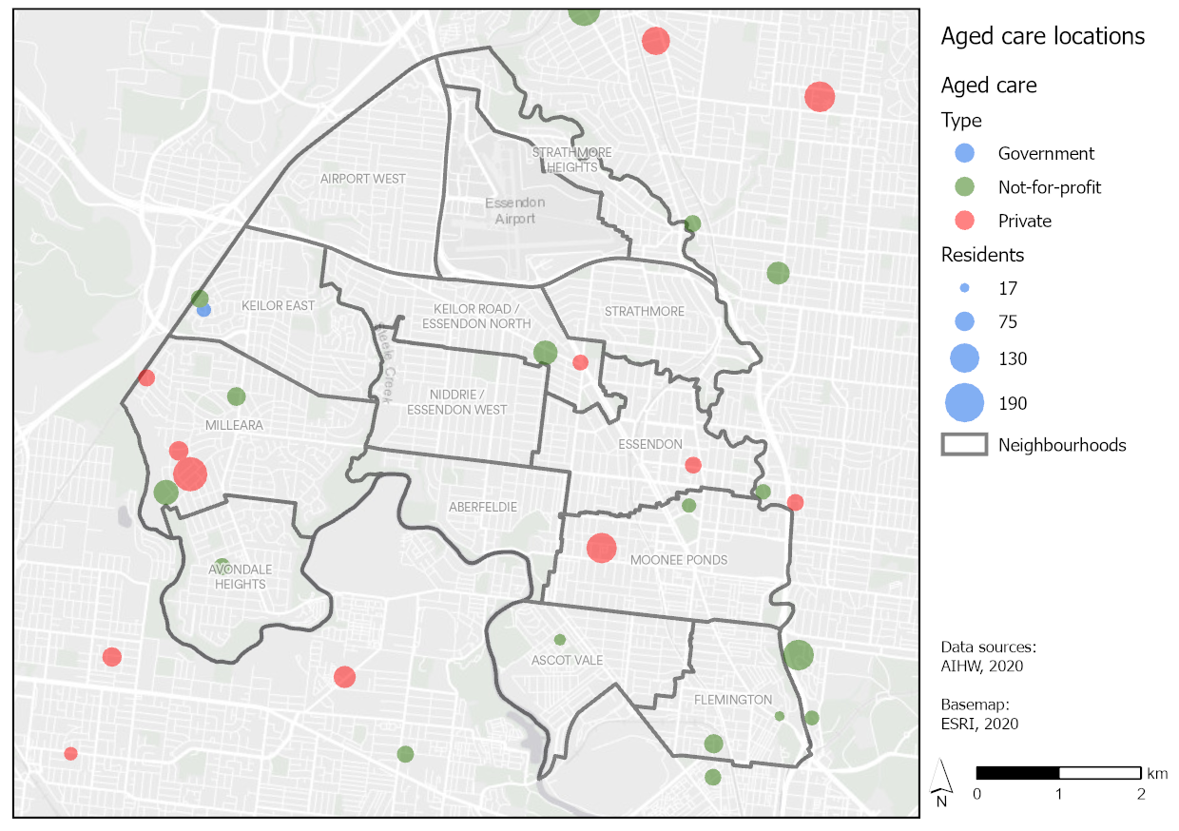
Source: AIHW, Aged Care Service List, 2020

Impact of COVID-19 on socioeconomic position among Moonee Valley target populations

Children: Formal education has been challenged during the pandemic as a result of working and studying from home as well as difficulties in access to internet connection and electronic devices (i.e. laptops and ipads).
Women: have experienced a greater rate of unemployment during the pandemic. The majority of casual workers unable to access job keeper are women; 55per cent of job losses due to the pandemic were among women; and women's unemployment has increased five-fold since the crisis (Gender Equality Victoria, 2020). Women have also had a larger responsibility of caring responsibilities and amounts of unpaid work (VicHealth, 2020).
Asylum seeker, refugee and people from CALD backgrounds and international students: are disproportionately impacted, being overrepresented in highly casualised and low-income industries that have been heavily affected by COVID-19, such as hospitality and retail (Koy, 2020). Those on temporary visas have been largely excluded from federal support packages, impacting on financial security (VicHealth, 2020).
Young people: are more likely to work in frontline services such as cafes, restaurants and bars than older people. Closure of businesses and reduced hours may have caused financial insecurity and mental distress.
Older people living in residential aged care and their carers: Most of the deaths due to COVID-19 in Victoria have occurred in aged care facilities. Data from the Department of Health and Human Services shows that within the municipality, there were a total of 245 deaths spread across four aged care facilities. Lockdowns in aged care disrupted regular visitations adding to the stress and isolation of these residents and their family and friends.
People experiencing homelessness and at risk of homelessness: are at higher risk of contracting COVID-19 during the pandemic due to limited access to safe and affordable housing and personal protective equipment. Insecure, overcrowded housing, such as rooming houses, make self-isolation and the ability to maintain personal hygiene harder, increasing the risk of getting COVID.

Social and community networks

Key points:
- Majority of residents feel part of their local community (67 per cent). The score was highest in Strathmore Heights (75) and lowest in Avondale Heights (57)
- Majority of residents trust their neighbours (82 per cent)
- Volunteering rates are lower compared to other metropolitan municipalities
- 21 per cent of households had no internet access in 2016; with 37% of people aged over 65 having no internet access
- Family violence rates in Moonee Valley are lower when compared with the municipalities in the North West Metro region, however the frequency in Moonee Valley has increased by 3.1 per cent from 2020 to 2021
- Ascot Vale, Essendon and Flemington had the three highest recorded incidences of Family Violence (in 2018)
- Less than half of residents feel safe walking alone at night, and men reported feeling safe more than women (32 per cent for women: 61per cent for men)

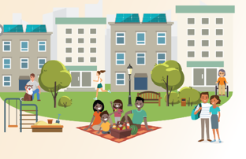

Social connection and inclusion

The connections that we form at an individual and community level are an important contributor to mental and physical health. The quality and quantity of our social relationship have been linked not only to mental health but also to morbidity and mortality. People with more positive social connections are more likely to live longer, and report higher levels of quality of life. There has been emerging evidence that the impact of social isolation and loneliness on health and mortality are more damaging than physiological conditions such as high blood pressure, obesity and smoking - making social connection an important public health issue (Lim, Holt-Lunstad, & Badcock, 2020). Social inclusion can also enable people to access resources such as social/emotional support, information and assistance .

Moonee Valley City Council’s annual community survey asks question about social and neighbourhood connection. These include feeling part of the local community and feelings of trust. On average in 2021, adults in Moonee Valley reported a score of 65 out of 100 when asked if they felt part of the local community. Higher scores indicate greater feelings of community connection. The score was highest in Strathmore Heights (75) and lowest in Avondale Heights (57). When looked at separately for males and females there was no difference.

Figure 39. Community connection
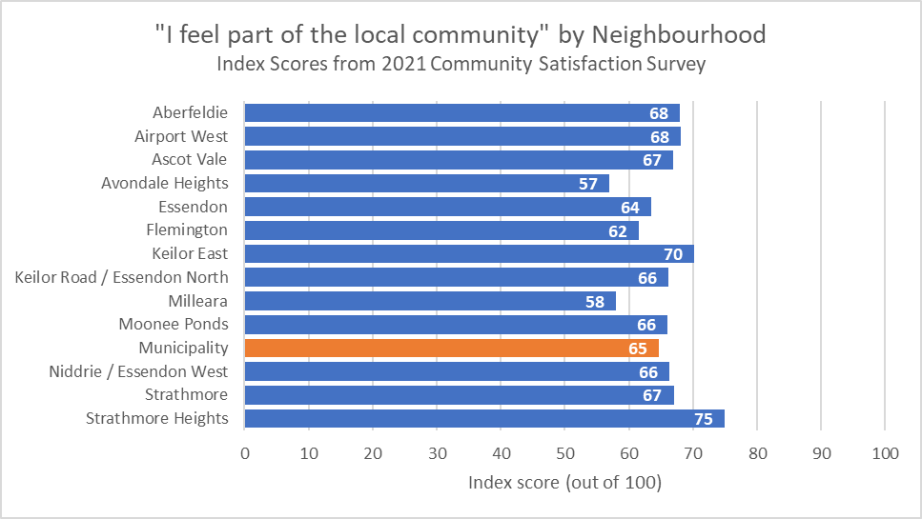
Source: Moonee Valley City Council annual community survey, 2020
Figure 40. Community connection annual trends, 2019-2021
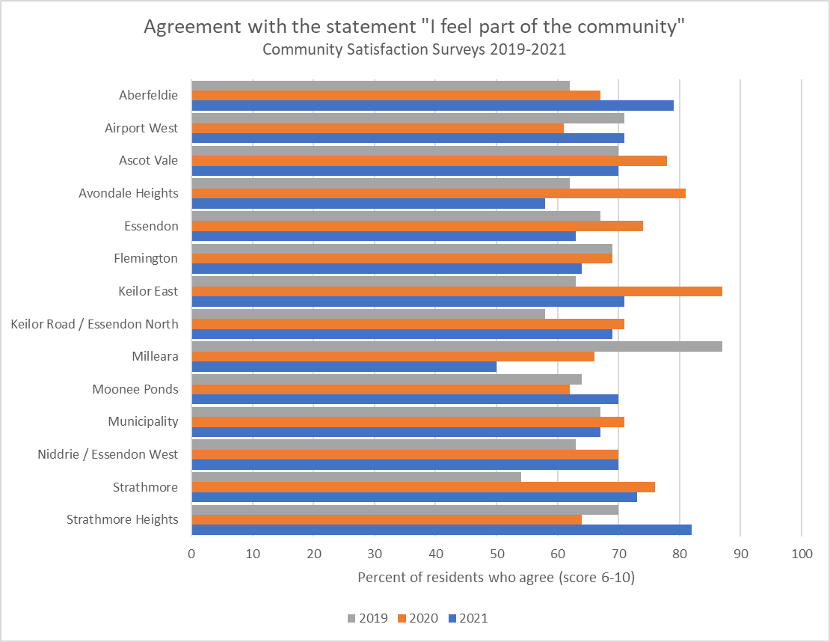
Source: Moonee Valley City Council annual community survey, 2020

Moonee Valley adults reported on average a score of 71 out of 100 when asked if people in this neighbourhood can be trusted. Higher scores indicate more trust. The score was highest in Aberfeldie (76), Keilor East (76), Strathmore (76) Strathmore Heights (76), and lowest in Flemington (67). When looked at separately for men and women there was little difference, with men reporting on average a score of 71 and women 72.

Figure 41. Neighbourhood trust
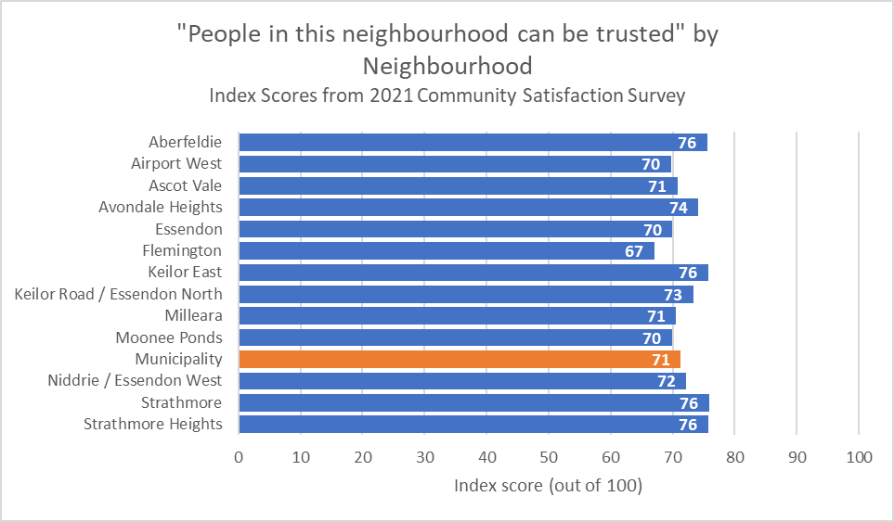
Source: Moonee Valley City Council annual community survey, 2020

Volunteering
Volunteering is also another indicator of social and neighbourhood connection. According to the 2016 census, Moonee Valley residents reported volunteering at a similar percent to greater Melbourne (17.8 per cent and 17.6 per cent respectively), but less than the Victorian average (19.2per cent)

Figure 42. Per cent of population who volunteer with an organisation or group

Source: Census data, 2016 compiled by REMPLAN

Digital inclusion
Information about what is happening in the world can be gained through internet access. The ABS defines internet access through using desktop/laptop computers, mobile or smart phones, tablets, music or video players, gaming consoles, smart TVs, and includes Internet access through any type of connection including ADSL, fibre, wireless, satellite and mobile broadband (3G/4G). In 2016, 21.8 pe cent of Moonee Valley household were without internet access; and this was more pronounced among older adults. For example 64.8 per cent of people aged over do not have internet access.
Figure 43. Digital inclusion
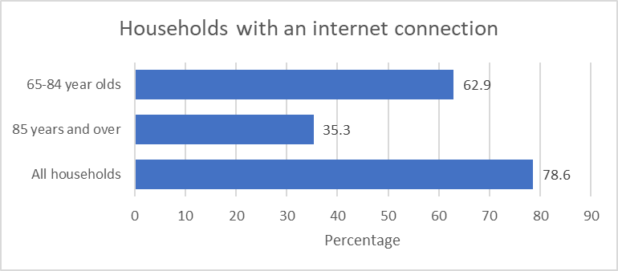
Source: 2016 census

Family violence
Although social connections are important for health and wellbeing, there are instances where this is not the case. Research has found that it is the quality of relationships that matter - more than the number of people you know (Lim, Holt-Lunstad, & Badcock, 2020). Toxic relationships experienced by those at risk of family violence are harmful for health. Family violence refers to violence between family members, including current or former intimate partners. While family violence can affect anyone, it is overwhelmingly experienced by women and children (Victorian Government, 2019). One Australian woman is murdered every week by her current or former partner, and nearly one in five women report being subjected to violence at some time in their adult lives (VicHealth, 2014). Family violence is the leading cause of death and disability in women aged 15-45 years and is the biggest contributor to women's ill-health, including poor mental health. Family violence is the single largest driver of homelessness for women, and a common factor in child protection notifications (Women’s Health West, 2021).

Domestic violence is a subset of family violence, which refers to violent behaviour between current or former intimate partners and includes physical, sexual, financial, emotional or psychological abuse and coercive control (AIHW, 2018). Elder abuse is a form of family or domestic violence that is experienced by older people. Like family violence, elder abuse is about having power and control over another person. Elder abuse is defined as “any action, or deliberate inaction, by a person in a position of trust which causes harm to an older person”. Most commonly it involves physical, sexual, psychological, emotional and financial abuse, and neglect (Domestic Violence Resource Centre Victoria, 2020). In Australia, it is estimated that elder abuse is experienced by 2-6 per cent of older people (National Ageing Research Institute, 2015).

Data from the Crime Statistics Agency shows that family violence rates in Moonee Valley are lower when compared with the municipalities in the North West Metro region, however there has been an increase in incidents of 3.1 per cent from 2020 to 2021. Ascot Vale, Essendon and Flemington had the three highest recorded incidences of Family Violence in 2018.

Figure 44. Family violence incidents
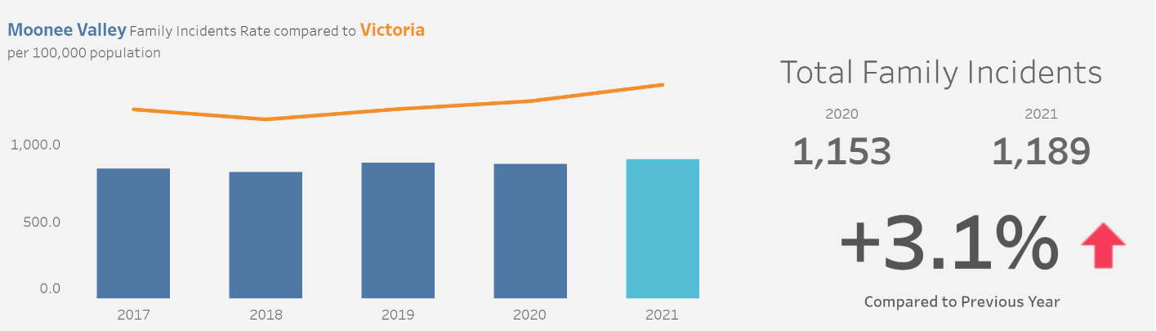
source: Latest crime data by area | Crime Statistics Agency Victoria (Year ending March 2021)

Community safety
Neighbourhoods which are perceived as safe, foster community participation, encourage physical activity, and add to the health and well-being of local residents and visitors. The built environment and the way neighbourhoods are designed and maintained, impact greatly on perceptions of safety (Wong et al, 2016). Data from Council’s annual community survey shows small variations in perceptions of safety over time (2018 to 2020). About eight in ten residents feel safe at public transport stops and stations, while about nine in ten residents feel safe when walking alone in their local area during the day. Less than half of all residents feel safe walking alone in their local area at night.

Figure 45. Perceptions of community safety (per cent feeling 'safe' or 'very safe')

Source: Moonee Valley Community Satisfaction Surveys, 2018-2021

Perceptions of safety of walking alone in the local area at night are much lower for females than for males. In 2021, 31.9 per cent of females reported feeling either ‘very safe’ or ‘safe’ compared to 64 per cent for males. There is no consistent trend over the period 2019 to 2021, although it should be noted that women felt less safe in 2021 than they did in 2020.

Figure 46. Residents who feel safe or very safe walking alone in their neighbourhood at night, by year and sex

Source: Moonee Valley City Council annual community survey, 2020

COVID-19 impact on social and community networks on target populations

Limits on public gatherings as well as social distancing have been imposed across Australia to limit the spread of COVID-19. During lock-downs, a variety of measures have been and are imposed to restrict movement. This has led to many social impacts such as cancellation of social gatherings, and the closure of community facilities. VicHealth research has shown that groups that were feeling less connected during Covid-19 lockdown restrictions include those with a self-reported disability (3 per cent), those who were unemployed (36 per cent), those in a lower income bracket (30 per cent), and young people aged 18 to 24 (39 per cent). Those speaking a language other than English at home (39 per cent) and Aboriginal and Torres Strait Islanders (51 per cent) were also more likely to report difficulties maintaining connections (VicHealth, 2020). However, there have been reports of positive consequences:
- residents spending more time with their families
- residents having more connection with their local community

Older people: are particularly at risk of social isolation due to COVID-19. This is especially the case with social and community groups not running. It has been suggested that ageism may also play a role in responses to the pandemic, putting older people more at risk of negative health and wellbeing consequences (Aronson, 2020).

LGBTIQA+ people: are more likely to experience anxiety and depression and greater risk of suicide and self-harm. Connection to community and peer support was disrupted potentially leading to greater mental health issues (Carman, Bourne and Fairchild, 2020).

Family violence: With people spending more time at home due to COVID-19 restrictions, those who were vulnerable to family violence before the pandemic are likely to be even more vulnerable now. A number of support agencies, as well as Victoria Police, anticipate increases in family violence cases with increased requests for help following lockdowns (Gearin and Knight, 2020).

Digital exclusion: Many people are relying on internet access to do their work, study, keep connected and access information. Older people are less likely to have access than younger people. Many residents who previously relied on using the internet at the libraries where unable to do so when libraries were closed.

Neighbourhood and environmental conditions

Key Points
- 13.6% of land in Moonee Valley is made up of open space reserves
- Tree canopy coverage was 17% in 2018
- Airport West and Keilor East had the lowest proportion of green canopy cover
- 19% of employed Moonee Valley residents travel to work by public transport. This ranges from less than 10 per cent in Keilor East to as high as 33 per cent in Flemington.
- Areas of neighbourhood level socio-economic disadvantage in Flemington, Ascot Vale, Avondale Heights and Milleara
- The areas with higher likelihood of urban heat islands are in Keilor East and Milleara
- Accessibility to open spaces and infrastructure concentrated around the Eastern areas of the municipality (e.g. Moonee Ponds, Essendon, Ascot Vale)

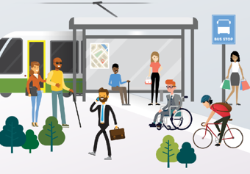
The health and wellbeing of individuals and communities is often determined by the natural and built environment that surrounds them. For example, highly connected street networks and diverse land-uses have all been linked to increased levels of physical activity and lower rates of obesity and morbidity including from heart disease and type-2 diabetes (Brown et al, 2009; Ewing & Cervero, 2010). Similarly, public parks and gardens can promote better physical and mental health by increasing levels of physical activity and reducing stress (Guite et al, 2006). The design of the built environment can also influence crime and perceptions of safety (Hong & Chen, 2014).

Climate stability and impact on health

Climate change has been declared as ‘the biggest global health threat of the 21st century’ (Costello et al, 2009). A changing climate and extreme weather events may have direct or indirect population health and wellbeing impacts. The 2016, US Global Change Research Program summarises:
“Rising greenhouse gas concentrations result in increases in temperature, changes in precipitation, increases in the frequency and intensity of some extreme weather events, and rising sea levels. These climate change impacts endanger our health by affecting our food and water sources, the air we breathe, the weather we experience, and our interactions with the built and natural environments. As the climate continues to change, the risks to human health continue to grow” (Kim, 2016).

The Victorian Government lists a number of key concerns and impacts of climate change for the Health and Human Service system in Victoria (Department of Health, 2021):
- Direct impacts to health and wellbeing from extreme weather events (e.g. bushfire, flood, drought, heat wave, etc)
- Indirect impacts to health and wellbeing (e.g. vector borne, water borne, food borne, zoonotic disease)
- Impacts on determinants of health and wellbeing such as employment, income, access to health and human services
- Disproportionate impacts on different communities, genders, and age groups
- Disruption to service delivery
- Damage to infrastructure (e.g. hospitals and housing)

Figure 47 shows how climate change can impact on physical, mental and community health. People are more likely to be vulnerable to climate change if they experience socio-economic disadvantage, are young children, older, and live with disabilities (Kim, 2016).

Figure 47. Climate change impacts on health

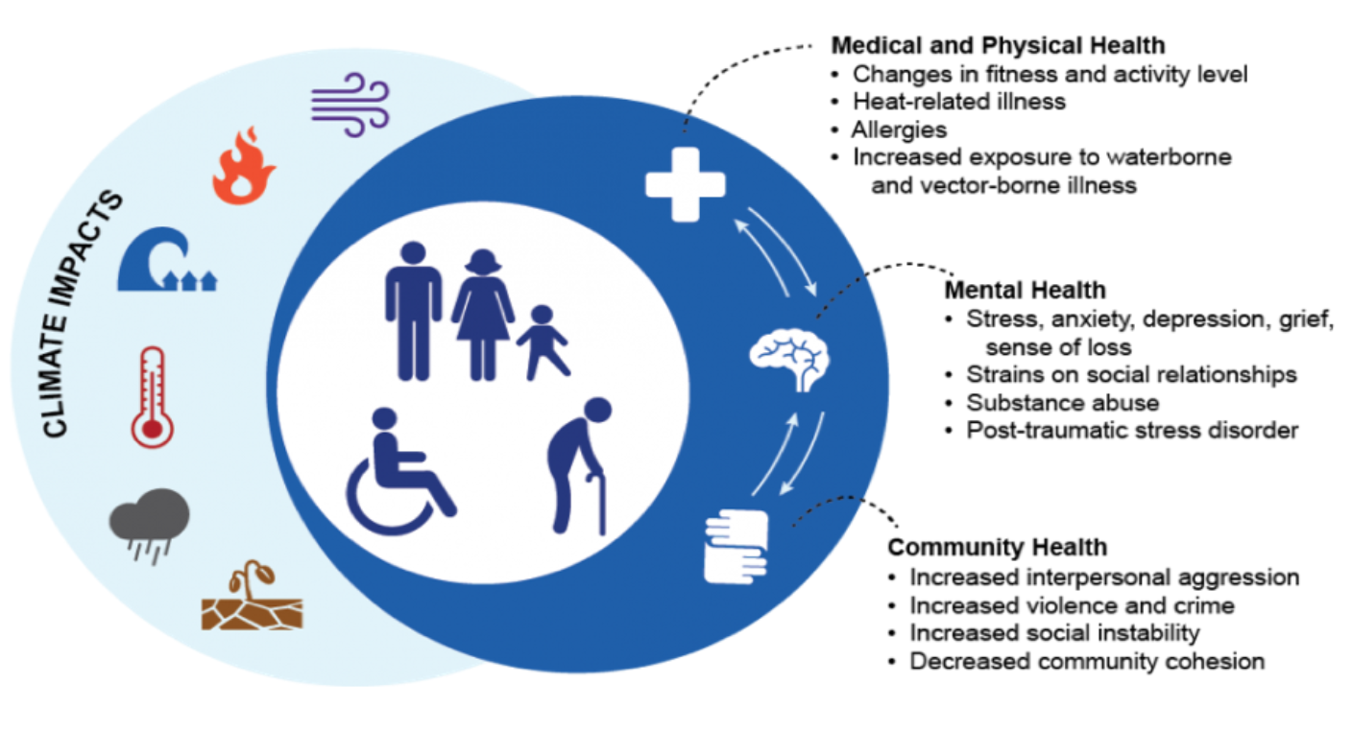source: Kim, 2016. https://health2016.globalchange.gov

Health impact: Heat stress
Poor thermal capability of housing – either too hot or too cold, can impact on health. The thermal capability of housing will become more important as extreme temperatures increase as will the need for safe public spaces. Vulnerable people, including older people, and parents with young children, and people living in public housing, may need to seek relief in council managed air- conditioned leisure centres, libraries, shopping centres, community centres and swimming pools.

Health impact: Psychological distress from extreme weather events
In 2019 a survey by Sustainability Victoria found that most Victorians feel some level of frustration and other negative emotions when they think about climate change such as feelings of sadness, outrage and despair. The report found that young people may be more prone to feelings of anxiety about their future than the rest of the population (Victorian Government, 2020).

The lived experience of extreme weather events such as bushfires, floods, droughts and heatwaves can contribute to anxiety, depression, post-traumatic stress disorder (PTSD), complicated grief, survivor guilt, recovery fatigue, substance abuse, and suicidal ideation (Hayes et al., 2018). The increased frequency and severity of extreme weather events is associated with an increase in family violence and abuse (Sorensen et al., 2018). All these possible negative health and wellbeing consequences make climate change an important public health issue.

Urban Heat Islands
Heat islands are urbanised areas that experience higher temperatures than outlying areas. Structures within the built environment such as buildings, roads, and other infrastructure absorb and re-emit the sun’s heat more than natural landscapes such as forests and bodies of water (Elgendawy and Davies, 2019). The Urban Heat Island (UHI) is a measure of urban temperatures relative to a non-urban areas. Native vegetated sites were used to establish the baseline (i.e. non-urban areas). The 2018 urban heat data layers show how many degrees Celsius the average temperature within urban parts of each boundary area is above or below the non-urban baseline. In Moonee Valley neighbourhoods in the east such as Keilor East and Milleara have higher temperatures.
Figure 48. Urban heat island (UHI) based on DELWP's Cooling and Greening Melbourne study
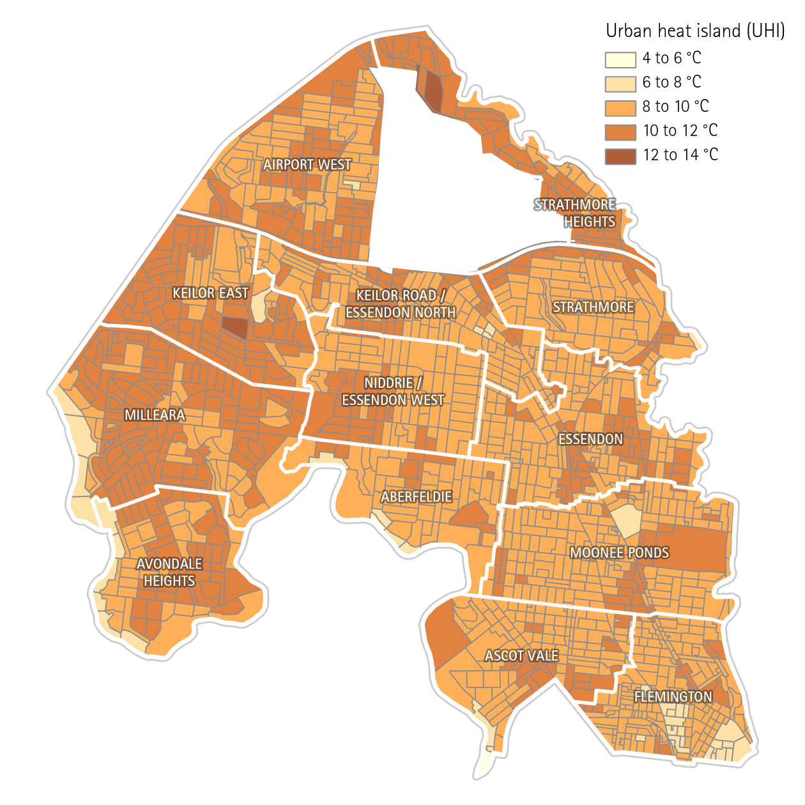

Natural environment

Public green open space
Attractive, safe and accessible open spaces have positive social, economic and environmental benefits for the community and are known to improve public health, wellbeing and quality of life. Green open spaces have a positive impact on mental health, and are particularly beneficial for people living in socioeconomically disadvantaged areas (Darven et al, 2018). Public open space typically refers to areas that are publicly accessible, have some greenery, and generally support some recreational activity. This usually includes parks, sports fields and nature reserves. Moonee Valley has 220 parks, gardens and open space reserves that cover around 13.6 per cent of the municipality by area (528 hectares). The areas depicted by green shading show public green open space (figure 49).

Figure 49. Public open space
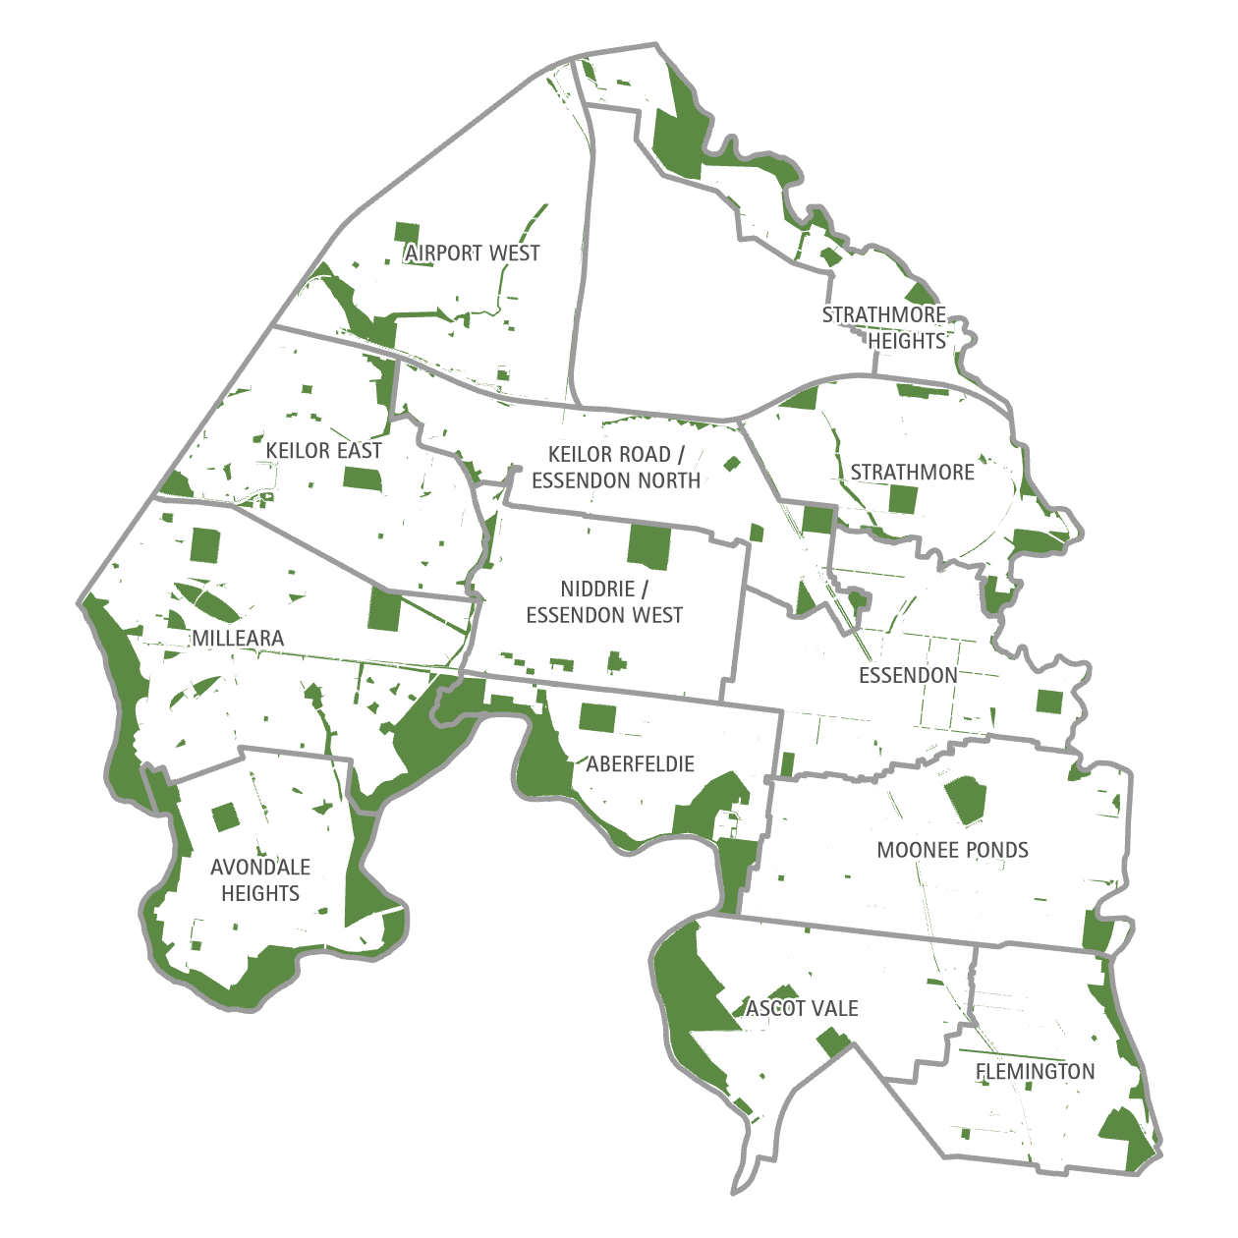

Tree canopy cover
Tree cover canopy can reduce health impacts of heat waves, as well as reducing UV exposure. In 2018, the tree canopy cover was 17 per cent of total land area. Airport West and Keilor East had the lowest proportion of green canopy cover in 2018, and Strathmore had the highest.
Figure 50– 2018 tree canopy cover estimates by neighbourhood catchment

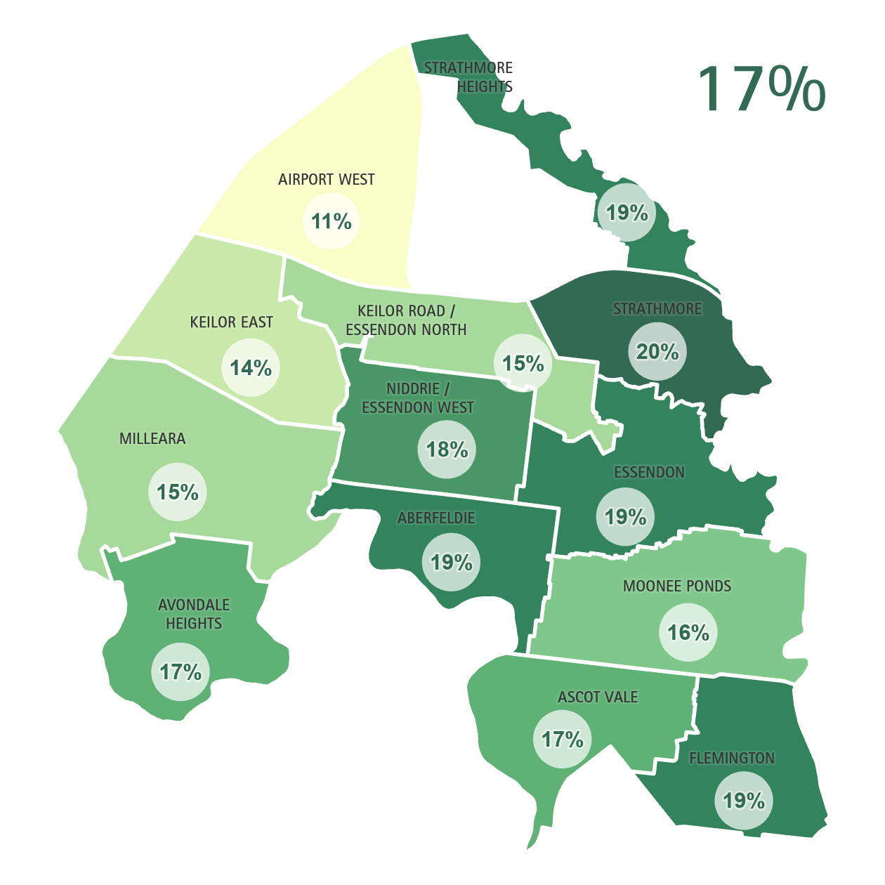

Physical and built environment

Neigbourhood level disadvantage

The SEIFA Index of Disadvantage measures the relative level of socioeconomic disadvantage in one area compared to others. The index is derived from attributes that reflect disadvantage such as low income, low educational attainment, high unemployment, and jobs in relatively unskilled occupations. A higher score on the index means a lower level of disadvantage. Moonee Valley is relatively advantaged when compared to other local government areas in Victoria and is in the eighth decile on the Index of Relative Socio-Economic Disadvantage (ten equal groups, with decile 10 being the most advantaged)

Table 10. Socio-Economic Indexes for Areas (SEIFA) indices, rank for Moonee Valley
Index | Score | Rank | Decile | Percentile
Relative Socio-economic Disadvantage (IRSD) | 1035 | 62 | 8 | 77
Source: ABS, Census 2016; (comparisons with other municipalities in Victoria)

The SEIFA Index of Relative Socio-economic Disadvantage (IRSD) also shows that there is great socio-economic diversity across Moonee Valley neighbourhood areas. There are areas of disadvantage in neighbourhoods such as Flemington, Ascot Vale, Avondale Heights and Milleara, with many areas in the most disadvantaged deciles (i.e. 1-2). In contrast, Strathmore and Strathmore Heights are the least disadvantaged neighbourhoods. This disparity is shown in Figure 51. The areas of most disadvantage in Moonee Valley are the public housing estates in Flemington and Ascot Vale (shaded darker red/brown) which are among the most disadvantaged neighbourhood areas in Australia (Figure 51).

Figure 51. Socio-Economic Indexes for Areas (SEIFA) ranking statistical areas relative socio-economic disadvantage, ABS
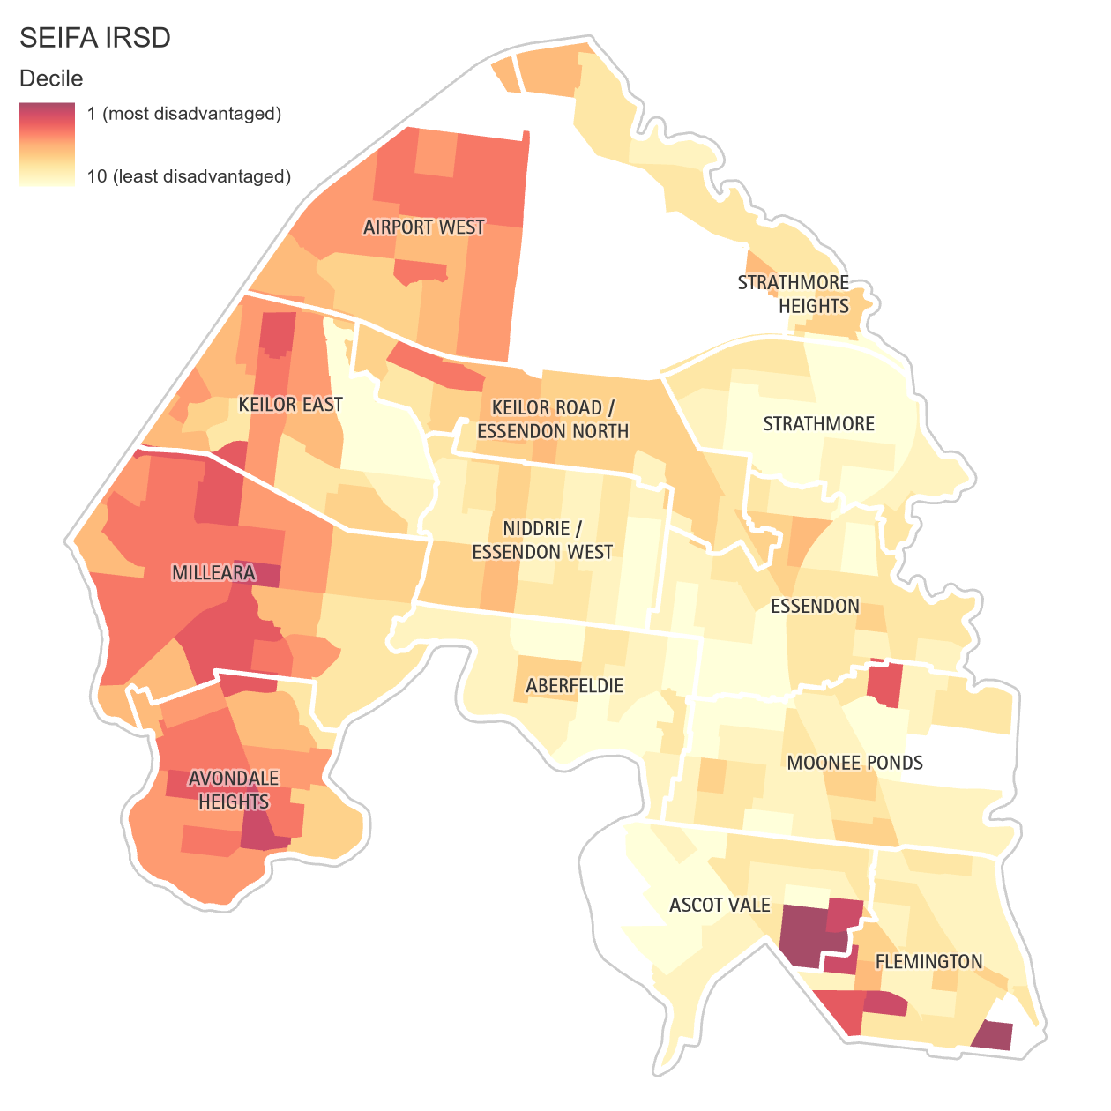

Walkability
Walkability refers to how well the built environment in different areas supports walking to local destinations or for transport. Walkable communities are good for health, traffic management and the environment. A combination of higher residential densities, well-connected street networks and mixed land uses are positively associated with people walking (for transport) to local destinations. Neighbourhoods with connected streets, higher population density and various local destinations (e.g., jobs, shops, services,) are considered more “walkable” than those in sprawling areas with cul-de-sacs, lower population densities, and fewer local destinations (RMIT, 2018).

Public transport networks
Around 19 per cent of employed Moonee Valley residents travel to work by public transport and ranges from less than 10 per cent in Keilor East to 33 per cent in Flemington (ABS Census, 2016). Public transport is more accessible in the south-east of the municipality. Overall 94 per cent of Moonee Valley residents live within either 800 metres (10 minute walk) of a train station, or 400 metres (five-minute walk) of a tram or bus stop (PTV data 2017 and 2016 Census).

Combined accessibility
Moonee Valley City Council has a few areas that are considered to have substantial combined accessibility – defined as 20-minute walk to public transport, open space, community facilities, schools and convenience centres. These are indicated by the purple shading in Figure 52 and include areas in Flemington, Moonee Ponds and Essendon. Conversely, as indicated by the brown shading, there are many areas that are considered to have low combined accessibility.

Figure 52. Accessibility within a 20-minute walk to public transport, open space, community facilities, schools and convenience centres.

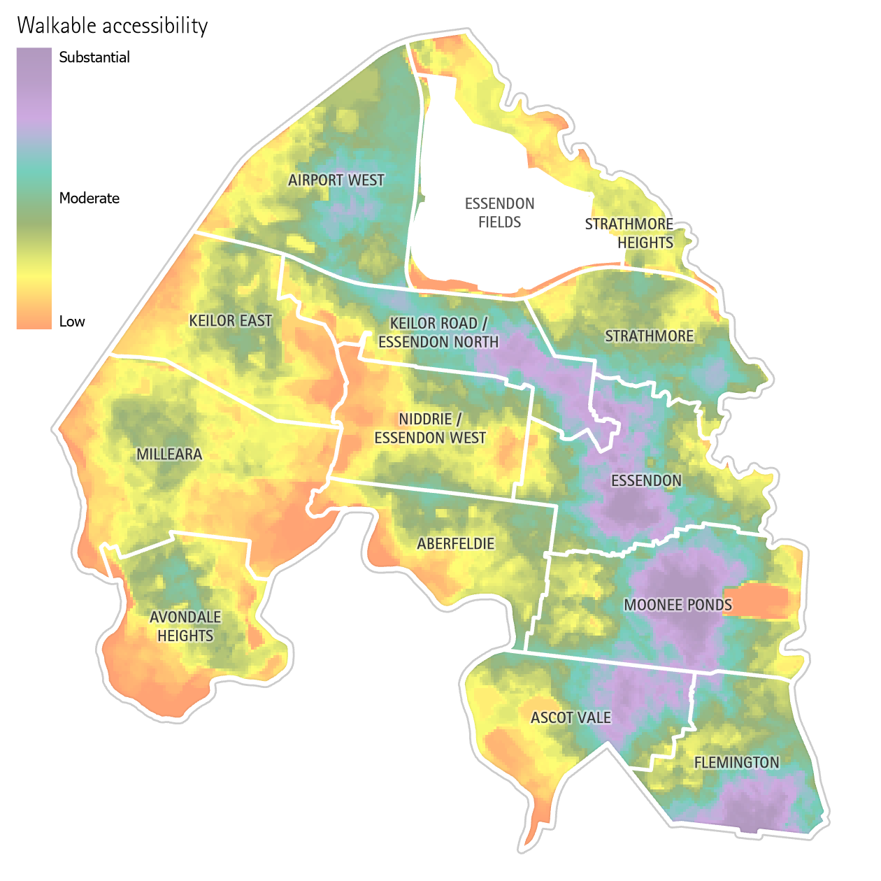

Health and wellbeing outcomes

Key points
- Moonee Valley’s residents enjoy good self-reported general health compared to those in other metropolitan municipalities, however self-reported general health is getting worse (i.e. 2021 - 59.2 pe cent of women reported excellent or very good health compared to 70.1 per cent in 2019; men 2021 - 62.2 per cent, 2019 -64.% per cent
- Adults from Airport West had the lowest levels of reporting very good or excellent health (47.6 per cent), whereas adults from Strathmore Heights had the highest levels of reporting very good or excellent health (68.4 per cent)
- Mental health among Moonee Valley’s residents is poorer than other metropolitan municipalities
- Young people aged 12-25 in Moonee Valley experience poorer levels of mental and emotional wellbeing compared to other Victorians. (e.g. 19.5 per cent Victorian average 13%)
- Falls are the leading cause of injury requiring admission to emergency department
- Coronary heart disease is the leading cause of death
- Alzheimer’s disease is likely to increase given the ageing population
- Climate related health impacts are an emerging issue

Health reflects the complex interactions of a person’s genetics, lifestyle and environment. The study of public health is focused on understanding the causes and consequences of health and disease in the community, and on improving health and wellbeing through addressing the disparities in health status between groups in our society. There are a number of indicators that can be used to identify the health status of the Moonee Valley community, paying particular attention to any health inequities within our target populations. These include:
- Life expectancy at birth
- Self-reported health
- Chronic disease
- Dental health
- Sexual and reproductive health
- Injury
- Deaths

Life expectancy

Australia has a relatively high life expectancy compared to other countries and life expectancy is predicted to increase over time. However, life expectancy is experienced unevenly and is affected by country of birth, sex, social and economic disadvantage, and discrimination. Life expectancy in Moonee valley between 2017-19 was higher for women than men and ranged from 85.8 to 86.3 years for women and 81.9 to 83 years for men.

Self-reported level of general health

Data from the Victorian Population Health Survey 2017 shows that about 47.5 per cent of Moonee Valley adults reported either ‘excellent’ or ‘very good’ health. This is higher than for Victoria and the Western Melbourne Area (approximately 42 per cent).

Figure 53. Self-reported health (Excellent or very good health status

Source: DHHS, Victorian Population Health Survey, 2017
Women in Moonee Valley were more likely to self-report higher levels of health than men. About 42 per cent of men and 54 per cent of women reported ‘excellent’ or ‘very good’ levels of health.
Figure 54. Self-reported health status by sex, Moonee Valley

Source: DHHS, Victorian Population Health Survey, 2017
Data from Moonee Valley City Council community surveys indicates a worsening trend for women’s and men’s self-reported health. For example, in 2021, 59.2 per cent of women reported excellent or very good health compared to 70.1 per cent in 2019. For men it was 62.2 per cent in 2021, compared to 64.1 per cent in 2019.

Figure 55. Self-reported health

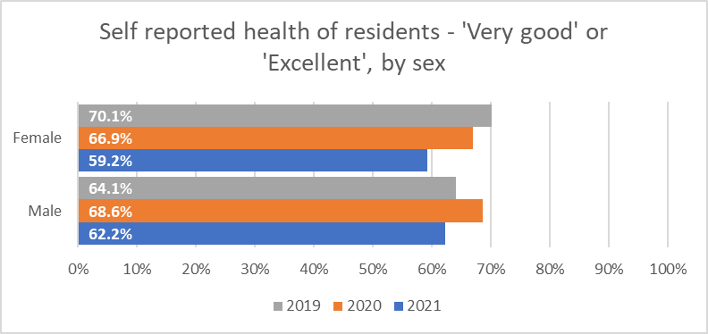
Source: Moonee Valley City Council Community Surveys 2019,2020,2021

Survey results from the Moonee Valley Community Survey show that in 2021, adults from Airport West had the lowest levels of reporting ‘very good’ or ‘excellent’ health (47.6 per cent), whereas adults from Strathmore Heights had the highest levels of reporting ‘very good’ or ‘excellent’ health (68.4 per cent).

Figure 56. Self-reported health of residents - 'Very good' or 'Excellent'

Source: Moonee Valley City Council Community Surveys 2019,2020,2021

Chronic disease

Chronic diseases are long lasting medical and health conditions that are not infectious or transmittable between people. The consequences of chronic disease can impact on peoples’ quality of life. Chronic conditions are becoming increasingly common especially in developed countries like Australia. In many instances, action can be taken to prevent their occurrence. Common chronic disease conditions include anxiety and depression, asthma, arthritis, cancer, heart disease, osteoporosis, type 2 diabetes, and stroke. Many people with chronic conditions do not have a single, predominant condition, but rather they experience multimorbidity—the presence of 2 or more chronic conditions at the same time (Australian Institute of Health and Welfare, 2021).

In Moonee Valley City Council in 2017, the most common chronic disease among adults was anxiety or depression (30.4 per cent) which was higher compared to the average Victorian proportion (27.4 per cent)
Almost a quarter (23 per cent) of residents in Moonee Valley live with two or more chronic diseases; this is slightly lower than for Victoria (25 per cent).

Figure 57. Doctor diagnosed chronic disease among adults in Moonee Valley

Source: DHHS, Victorian Population Health Survey, 2017

Screening and health tests for chronic disease
Prevention and treatment of chronic disease can be aided by screening and health tests. Data from the Victorian Population Health Survey 2017 shows that testing for chronic disease in Moonee Valley adults is similar to levels in Western Melbourne. Bowel examinations are lower, and faecal blood occult tests are higher than for Western Melbourne, although it should be noted these differences are not statistically significant (meaning these differences could be explained by chance).

Figure 58. Testing for chronic disease, %

Source: DHHS, Victorian Population Health Survey, 2017

Obesity
Obesity can contribute to chronic disease – especially diabetes and heart disease. Data from the Victorian Population Health Survey 2017 shows that almost half (48 per cent) of Moonee Valley adults are overweight, measured by their Body Mass Index (BMI). This figure is similar to the proportion in the Western Melbourne Area, and slightly lower than the Victorian average (51 per cent).
Figure 59. Pre-obese or obese adults

Source: DHHS, Victorian Population Health Survey, 2017

The estimated childhood obesity rates per 1000 children aged 2-17 in Moonee Valley in 2017 was lower (5.7 per cent) compared to Melbourne (7.2 per cent) for both males and females.

Figure 60. Childhood Obesity rate, by sex

Source: Health tracker atlas, data estimates from Australia’s National Health Survey, 2017.

Dental health

In 2014, poor oral health was the leading cause of preventable admissions to hospital for Victorians aged under 25 years and the second largest for all ages in Victoria. Most oral diseases are able to be prevented, however improving oral health requires access to healthy diets, fluoride in water and toothpaste, good oral hygiene, and regular preventive care through dental check-ups (Victorian Government, 2016). Data from the Victorian Population Health Survey shows that Moonee Valley adults have better self-reported dental health (43.5 per cent) when compared to the Western Melbourne Area (38.3 per cent) and Victoria (37.2 per cent). Approximately a third of Moonee Valley adults are likely to delay visiting a dental professional due to of cost (31.6 per cent), however this is less than compared to other Victorians (33.9 per cent).

Figure 61. Dental health indicators for adults

Source: DHHS, Victorian Population health Survey, 2017

Data from Dental Health Services Victoria shows that children in Moonee Valley aged 12 years are more likely to have a decayed tooth when presenting to public health dental services compared to younger ages. Across all age groups, Moonee Valley children are less likely to present at public health dental services with a decayed tooth when compared to Victorian children.

Figure 62. Children presenting with at least one decayed tooth to public health dental services, 2017

Source: Dental Health Services Victoria, 2019

Mental health
Mental Health is defined by the World Health Organisation as ‘a state of well-being in which every individual realises his or her own potential, can cope with the normal stresses of life, can work productively and fruitfully and is able to make a contribution to her or his community’ (WHO, 2018). The term mental health is also often used to describe mental health conditions such as anxiety, depression, and schizophrenia. Mental health illnesses can cause significant disruption to productivity, and quality of life. Data from the Victorian Population Health Survey 2017 shows that approximately eight in ten Moonee Valley adults reported very high or high feeling of life being worthwhile (79 per cent) and life satisfaction (78 per cent).

Figure 63. Self-reported mental wellbeing

Source: DHHS, Victorian Population Health Survey, 2017

The Victorian Population Health Survey 2017 also shows that approximately 30 per cent of Moonee Valley adults had ever been diagnosed with anxiety of depression. This figure is higher than both Western Melbourne (25 per cent) and Victoria (27 per cent).

Figure 64. Proportion of adults ever diagnosed with anxiety or depression

Source: DHHS, Victorian Population Health Survey, 2017
The 2017 survey shows that women in Moonee Valley were more likely to have lower scores on feeling life is worthwhile, higher levels of seeking professional help for mental health issues, and to have been diagnosed with anxiety or depression, compared to men.

Figure 65. Mental health indicators by sex, for Moonee Valley adults

Source: DHHS, Victorian Population Health Survey, 2017

Suicide rates
Data from the state coroner shows there was no increase in suicides in Victoria in 2020, compared to 2019 despite a spike of more than 40 per cent in calls for help to mental health hotlines (Coroners Court Victoria, 2020). Between 2013-2017, Moonee Valley City Council had a lower suicide rate per 100,000 than compared to Melbourne (7.8 out of 100, 000 and 9.1 out of 100, 000 respectively).

Sexual and reproductive health

Sexual and reproductive health (SRH) is a fundamental contributor to people’s optimal health and wellbeing (World Health Organization, 2010). Sexually transmitted infections (STIs) are sexually transmitted infections. Sexually transmitted diseases (STDs) are STI’s that cause disease.
Data from Women’s Health Victoria shows there are increasing rates of STIs, low uptake of contraception, low rates of cervical screening, as well as a lack of access to quality healthcare and health education in Victoria (Women’s Health Victoria, 2020).
The western metropolitan region of Melbourne is disproportionately impacted by poor SRH health outcomes. In Moonee Valley, rates of STDs including chlamydia, gonorrhoea and hepatitis B are lower than for the Metro West region, and are lower for females than males. In addition, while rates of gonorrhoea are lower in Moonee Valley than for the metro west region, they are still higher than the Victorian rates for males (6.6 per 10,00) and females (2.1 per 10,000).

Figure 66. Selected sexual and reproductive health indicators, by sex

Source: Women’s Health Victoria, Women’s Health Atlas, 2020

Injury

Injury may be intentional (e.g. caused by violence from another person) or unintentional (e.g. caused by falls and road accidents). The role of municipal public health covers prevention, early intervention and risk mitigation.

Falls
Falls are the leading cause of unintentional injury in older Australians. Experiencing a fall can trigger a loss of confidence in an older person and lead to an ongoing fear of falling. This can lead to the person limiting their movements and reducing their activity, which further increases the risk of falling due to declining physical health. Falls can also result in a permanent loss of mobility, or higher reliance on mobility equipment such as walking frames and wheelchairs, and carer assistance. Prior fall history is a major contributor to admission to residential aged care. Factors implicated in falls include hazardous home environments, uneven road and footpath environments. Indirect factors are limited availability or access to health services to prevent frailty and pre-existing health conditions (DHHS, 2018).

In 2018, falls were the leading cause of unintentional injury accounting for 2311 hospitalisations for Moonee Valley residents. In Moonee Valley the percentage of unintentional injuries caused by falls is the third highest in the state (45.9per cent compared to the Victorian average of 38.7per cent) (2018, Victorian Injury Surveillance Unit Monash University). It is important to note these statistics do not differentiate between whether falls occur in the home or the public realm.

Figure 67. Hospitalisations: Unintentional injury’s

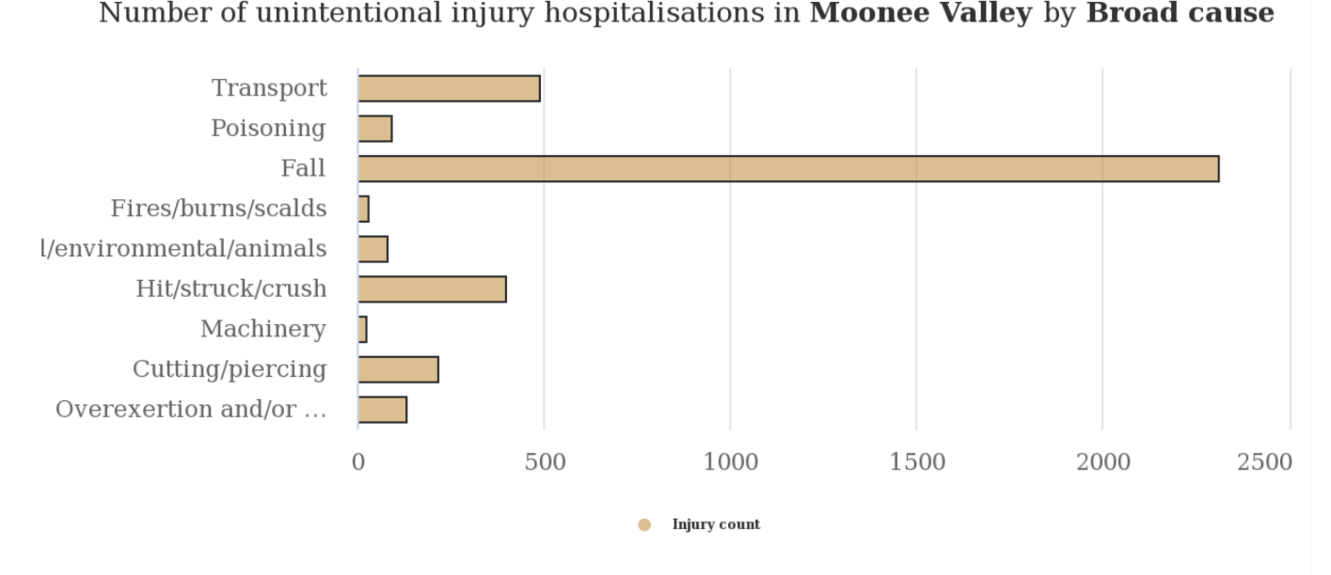
Source: 2018. Victorian Injury Surveillance Unit Monash University, published in the Injury Atlas Victoria.

Road related injury
Data compiled by VicRoads show that from the period 2014 to July 2019 there was 15 road related fatalities in Moonee valley, 226 serious injuries and 1,281 other injuries. A ‘serious injury’ is one requiring admission to hospital (and no death within 30 days). ‘Other injury’ requires medical treatment, but no hospitalisation, which could include for example bruising, soreness, pain, unconsciousness or a cut.

Figure 68. Road crashes from 2014 to 2019

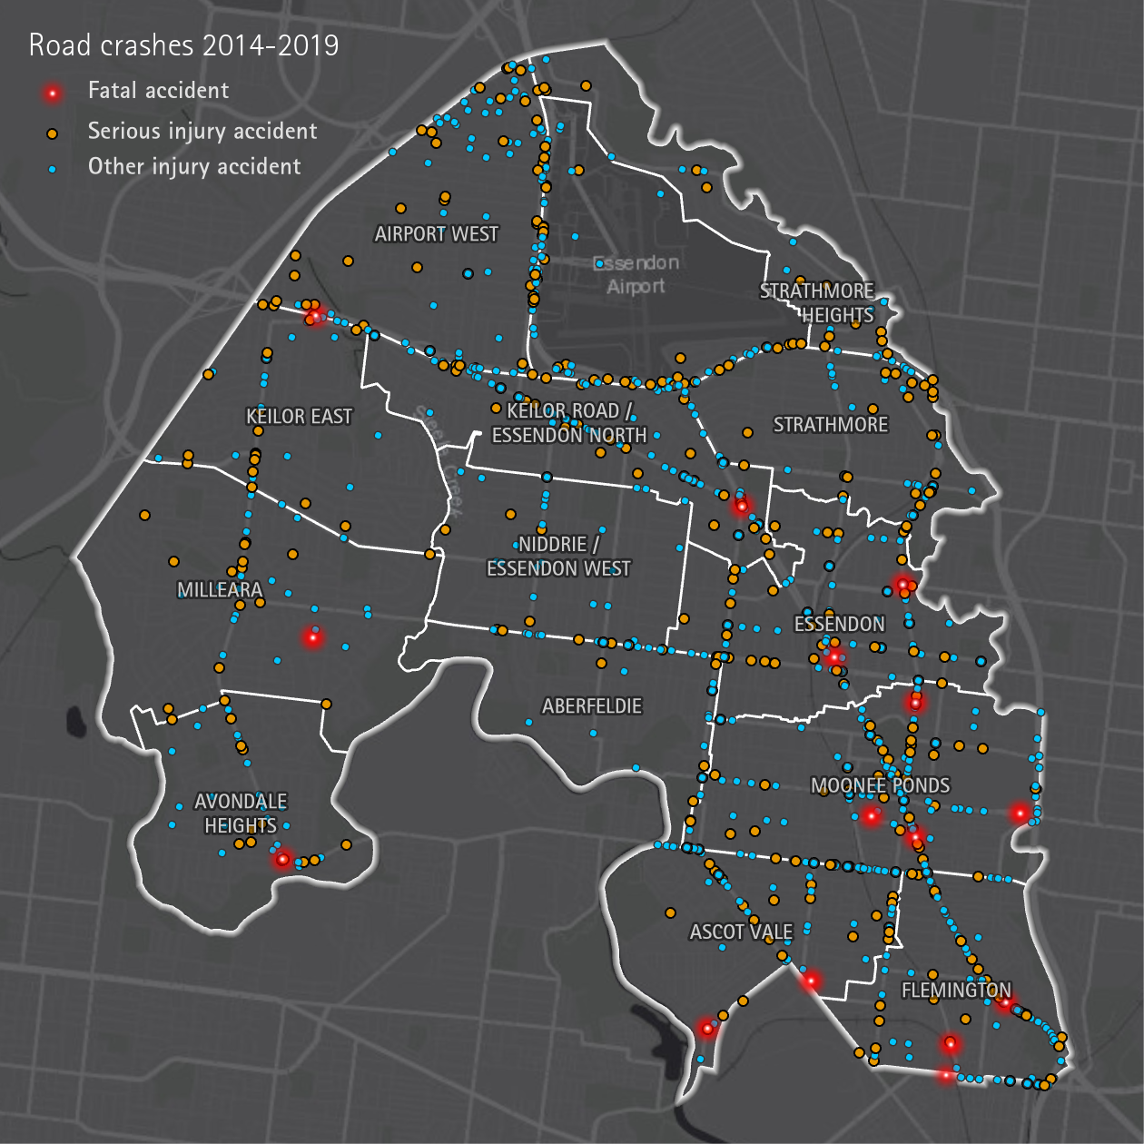
Source: VicRoads at Crash Stats

Deaths

As well as differences by sex, the leading causes of death also vary by age. In Australia, chronic diseases feature more prominently among people aged 45 and over, while the leading causes of death among people aged 1–44 are external causes, such as accidents and suicides (AIHW, 2021).

Table: 11 Australian Leading cause of death by ag group, 2016-2018
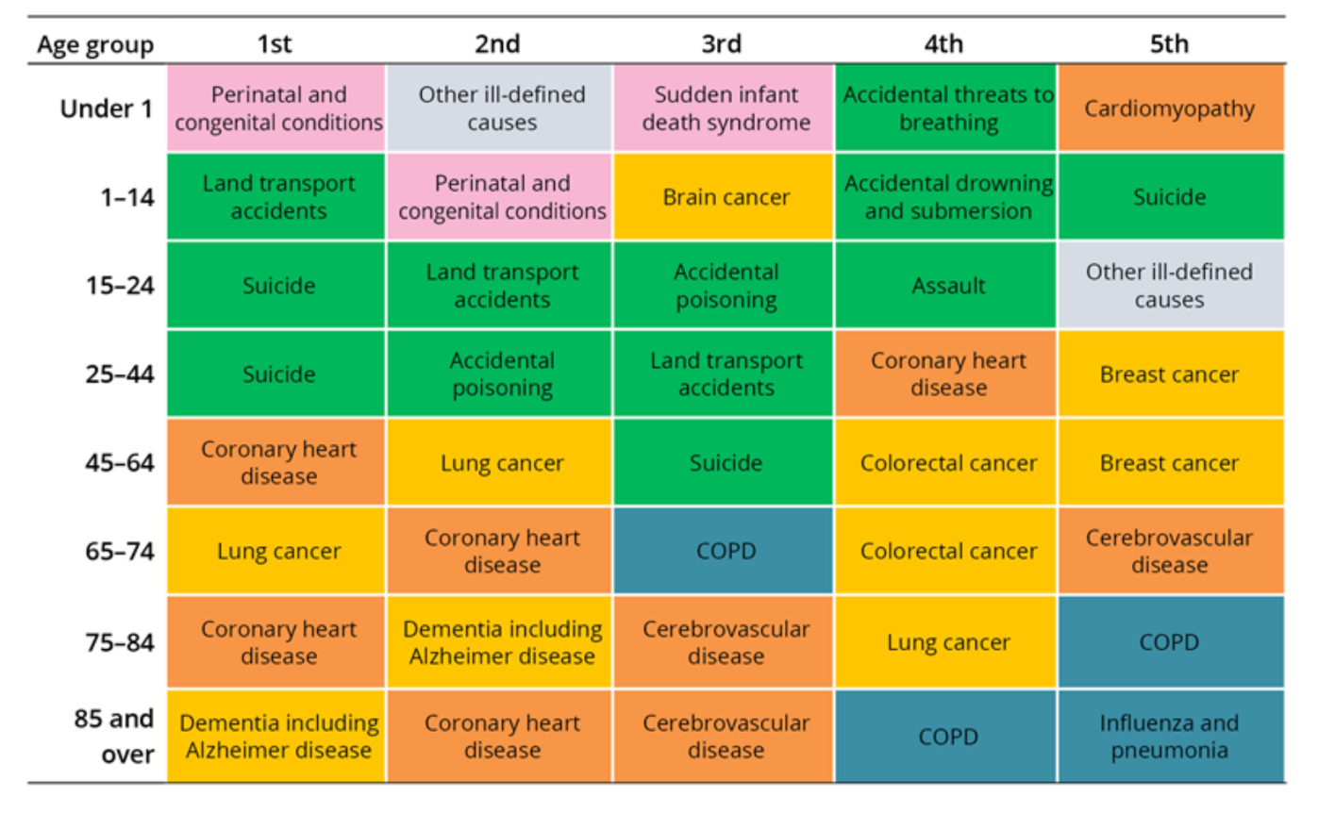
Source: https://www.aihw.gov.au/reports/life-expectancy-death/deaths-in-australia/contents/leading-causes-of-death

Causes of death – all ages
The most common cause of death for Moonee Valley in 2018 was coronary heart disease (12.8 per cent of all cases), responsible for 489 deaths. Dementia including Alzheimer’s disease was second leading cause of death with 295 cases.

Table 12: Top ten causes of death in Moonee Valley, 2018

Cause | Deaths | % of all causes
Coronary heart disease | 489 | 12.8
Dementia including Alzheimer disease | 295 | 7.7
Cerebrovascular disease | 241 | 6.3
Lung cancer | 173 | 4.5
Chronic obstructive pulmonary disease | 146 | 3.8
Colorectal cancer | 145 | 3.8
Diabetes | 122 | 3.2
Accidental falls | 118 | 3.1
Influenza and pneumonia | 83 | 2.2
Prostate cancer | 76 | 2.0
Source: AIHW, Mortality over Regions and Time, 2020

Summary of COVID-19 health and wellbeing impacts

This profile was developed as the world lives through the impacts of the COVID-19 pandemic. It is expected that the economic, health and social impacts of the COVID-19 pandemic will be felt by our community for decades to come, especially for those who are already vulnerable. The following provides a summary of the health and wellbeing impacts of the pandemic among Moonee Valley’s target populations highlighted in this profile:

- Mental health challenges (social isolation and loneliness, psychological distress, anxiety and depression)
- Increasing family violence, including elder abuse
- Increasing alcohol and drug use
- Physical activity (shift from organised sport to walking and cycling in local spaces)
- Steep rise in food insecurity especially among International Students and Asylum Seekers
- Increasing financial hardship (unemployment, housing stress)
- Increasing risk of homelessness, especially among socioeconomically disadvantaged and older women
- Widening digital divide among socioeconomically disadvantaged and older adults
- People who have a pre-existing health condition, such as diabetes, asthma, heart and lung conditions, or immune problems are at higher risk of developing a severe illness associated with COVID-19
- Non-urgent (or elective) surgeries have been postponed to free up beds and equipment, (Australian Broadcasting Corporation, 2020)
- People have been delaying visiting GPs for health check-ups (Ivynian et al, 2020)
- Many mental health services have closed or shifted to remote service during the pandemic.
It is important to note that the full impacts of the COVID-19 pandemic on all of the preventable contributors to poor health and wellbeing are yet to be fully realised.

Abbreviations

ABS Australian Bureau of Statistics
AIHW Australian Institute of Health and Welfare
DHHS Department of Health and Human Services (Victoria)
IRSD Index of Relative Socio-economic Disadvantage (this is one of the four SEIFA indices)
LGBTIQA+ Lesbian, Gay, Bisexual, Transgender, Gender Diverse, Intersex, Queer, Asexual and Questioning Communities
SA2 Statistical Area Level 2 (this is a geographical area that is part of the Australian Statistical Geography Standard)
SEIFA Socio-Economic Indexes for Areas - these are indices created by the ABS
SRH Sexual and reproductive health
STD Sexually transmitted disease
STI Sexually transmitted infection

References

Aronson, L., 2020 ‘Ageism Is Making the Pandemic Worse’, https://www.theatlantic.com/culture/archive/2020/03/americas-ageism-crisis-is-helping-the-coronavirus/608905/,
Carman, M, Bourne A, and J Fairchild, 2020, ‘COVID-19: impacts for LGBTIQ communities and implications for services: A Research Briefing Paper by Rainbow Health Victoria’. Melbourne: Rainbow Health Victoria, Australian Research Centre in Sex, Health and Society, La Trobe University, https://www.latrobe.edu.au/__data/assets/pdf_file/0006/1109481/Rainbow-Health-Victoria-Research-Briefing-Paper-COVID-19.pdf
Australian Broadcasting Corporation, 2020. ‘Elective surgery is going to resume as coronavirus restrictions ease. Here's what you need to know’, https://www.abc.net.au/news/2020-04-21/elective-surgery-restored-national-cabinet-cmo-coronavirus/12168848
Australian Bureau of Statistics, 2016, ‘Census of Population and Housing’, 2016, Australian Government, Canberra.
Australian Bureau of Statistics, 2018, ‘Census of Population and Housing: Estimating homelessness’, Cat. 2049.0, Australian Government, Canberra.
Australian Bureau of Statistics, 2019, ‘Regional Population by Age and Sex, Australia’, Australian Government, Canberra.
Australian Bureau of Statistics, 2018. ‘Disability, Ageing and Carers, Australia: Summary of Findings’. https://www.abs.gov.au/statistics/health/disability/disability-ageing-and-carers-australia-summary-findings/2018#data-download
Australian Bureau of Statistics, 2020, ‘Weekly Payroll Jobs and Wages in Australia’, Australian Government, Canberra. https://www.abs.gov.au/statistics/labour/earnings-and-work-hours/weekly-payroll-jobs-and-wages-australia/latest-release
Australian Health Policy Collaboration, 2017, ‘Australia’s Health Tracker Atlas’, Victoria University and Torrens University, https://atlasesaustralia.com.au/ahpc/,
Australian Institute of Health and Welfare, 2020, ‘Aged Care Service List’, Department of Health, Australian Government, Canberra, https://hwd.health.gov.au/datatool.html,
Australian Institute of Health and Welfare, 2020, ‘Mortality Over Regions and Time’, Department of Health, Australian Government, Canberra, https://www.aihw.gov.au/reports/life-expectancy-death/mort-books/contents/mort-books,
Australian Institute of Health and Welfare, 2020. ‘National Health Workforce Data Set’, Department of Health, Australian Government, Canberra, https://www.gen-agedcaredata.gov.au/resources/access-data/2019/september/aged-care-service-list-30-june-2019, accessed 22 September 2020.
Australian Institute of Health and Welfare, 2020, ‘National cancer screening programs participation data’, Department of Health, Australian Government, Canberra, https://www.aihw.gov.au/reports/cancer-screening/national-cancer-screening-programs-participation/contents/summary,
Australian Institute of Health and Welfare, 2021, ‘Chronic disease’ https://www.aihw.gov.au/reports-data/health-conditions-disability-deaths/chronic-disease/overview.
Australian Institute of Health and Welfare, 2021, ‘Deaths in Australia’ (https://www.aihw.gov.au/reports/life-expectancy-death/deaths-in-australia/contents/leading-causes-of-death).
Australian Institute of Health and Welfare, 2016, ‘4.1 Social determinants of health’
https://www.aihw.gov.au/reports/australias-health/australias-health-2016/contents/chapter-4-determinants-of-health
Australian Institute of Health and Welfare, Family, domestic and sexual violence in Australia 2018. Cat. no. FDV 2. Australian Government, Canberra 2018.
Better Health Channel, 2018, ‘Physical activity – it’s important’, Victorian Government, Melbourne,
<https://www.betterhealth.vic.gov.au/health/healthyliving/physical-activity-its-important>
Better health Channel, 2019. ‘Smoking- effects on your body’ https://www.betterhealth.vic.gov.au/health/healthyliving/smoking-effects-on-your-body
Brown, B.B., Yamada, I., Smith, K.R., Zick, C.D., Kowaleski-Jones, L. and Fan, J.X., 2009. Mixed land use and walkability: Variations in land use measures and relationships with BMI, overweight, and obesity. Health & place, 15(4), pp.1130-1141.
Camacho, D., 1999, The social, economic and industrial issues specific to migrant workers over 45 Years of age seeking employment, or establishing a business, following Unemployment (a quantitative approach), Standing Committee On Employment, Education And Work Place Relations (Submission 33), Australian Parliament House, Canberra
Coroners Court Victoria, 2020. ‘No increase in Victorian suicides under COVID-19, shows new coronial report’
https://www.coronerscourt.vic.gov.au/no-increase-victorian-suicides-under-covid-19-shows-new-coronial-report report)
Costello, A., Abbas, M., Allen, A., Ball, S., Bell, S., Bellamy, R., Friel, S., Groce, N., Johnson, A., Kett, M. and Lee, M., 2009. Managing the health effects of climate change: lancet and University College London Institute for Global Health Commission. The lancet, 373(9676), pp.1693-1733.
Crime Statistics Agency, 2020, ‘Latest Victorian Crime Data’, Victorian Government, Melbourne, https://www.crimestatistics.vic.gov.au/crime-statistics/latest-victorian-crime-data, accessed 22 September 2020.
Dahlgren, G., & Whitehead, M., 1991, Rainbow model of health. In European Health Policy conference: opportunities for the future (Vol. 11).
Davern, M., Farrar, A., Kendal, D. and Giles-Corti, B., 2017. Quality green space supporting health, wellbeing and biodiversity: A literature review.
Dental Health Services Victoria, 2020, ‘City of Moonee Valley Oral Health Profile’, Department of Health and Human Services, Victorian Government, Melbourne.
Department of Education, Skills and Employment, 2020, ‘Small Area Labour Markets’, Australian Government, Canberra, https://www.employment.gov.au/small-area-labour-markets-publication-0, accessed 22 September 2020.
Department of Environment, Land, Water and Planning, 2020, Heat Vulnerability Index, Victorian Government, Melbourne.
Department of Health, 2020. ‘What are the effects of alcohol?’ Australian Government, Canberra https://www.health.gov.au/health-topics/alcohol/about-alcohol/what-are-the-effects-of-alcohol
Department of Health, 2021, ‘Victorian coronavirus data’, Victorian Government, Melbourne, https://discover.data.vic.gov.au/dataset/victorian-coronavirus-data
Department of Health, 2021. Health and Human Services Adaptation Action Plan 2022-2026

Department of Health and Human Services, 2018. ‘Falls prevention among older Victorians’. (https://www2.health.vic.gov.au/public-health/chief-health-officer/cho-publications/your-health-report-2018/injury-prevention/falls-prevention)
Department of Health and Human Services, 2019. Victorian public health and wellbeing plan 2019–2023.
Department of Health and Human Services, 2020a. ‘Rental Report’, Victorian Government, Melbourne, https://www.dhhs.vic.gov.au/publications/rental-report, accessed 22 September 2020.
Department of Health and Human Services, 2020b, ‘Case locations and outbreaks’, Victorian Government, Melbourne, https://www.dhhs.vic.gov.au/case-locations-and-outbreaks, accessed 20 October 2020.
Department of Health and Human Services, 2017, Victorian Population Health Survey 2017, Victorian Government, Melbourne.
Department of Home Affairs, 2019, ‘Settlement data reports October 2019 – December 2019’, Australian Government, Canberra,<https://www.data.gov.au/dataset/ds-dga-8d1b90a9-a4d7-4b10-ad6a-8273722c8628/distribution/dist-dga-9f1aa933-a514-4301-a74a- b6c5e4adacd9/details?q=>,
Department of Home Affairs, 2020, ‘Illegal maritime arrivals’ https://www.homeaffairs.gov.au/research-and-stats/files/illegal-maritime-arrivals-bve-june-2020.pdf
Department of Home Affairs, 2019, ‘Illegal maritime arrivals’: https://www.homeaffairs.gov.au/research-and-stats/files/illegal-maritime-arrivals-bve-june-2019.pdf
Domestic Violence Resource Centre Victoria, 2020, ‘For older people’ <https://www.dvrcv.org.au/help-advice/elder-abuse-and-family-violence
Elgendawy, A. and Davies, P., 2019. ‘The urban heat island in Australian city planning’. In State of Australian Cities National Conference (9th: 2019).
Ewing, R. and Cervero, R., 2010. ‘Travel and the built environment: A meta-analysis’. Journal of the American planning association, 76(3), pp.265-294.
Foundation for Alcohol Research and Education, 2020. ‘Many Australians using more alcohol and worried about household drinking’, https://fare.org.au/many-australians-using-more-alcohol-and-worried-about-household-drinking/
Federation of Ethnic Communities’ Councils of Australia, 2015, Community Perspectives on Settlement Issues Affecting New and Emerging Communities in Rural and Regional Australia, <http://fecca.org.au/wp-content/uploads/2015/06/FECCA-Rural-and-Regional-report-June-2015-00000002.pdf>
Gearin, M., & Knight, B., 2020, ‘Family violence perpetrators using COVID-19 as 'a form of abuse we have not experienced before'’, ABC News, https://www.abc.net.au/news/2020-03-29/coronavirus-family-violence-surge-in-victoria/12098546,
Guite, H.F., Clark, C. and Ackrill, G., 2006. The impact of the physical and urban environment on mental well-being. Public health, 120(12), pp.1117-1126.
Hong, J. and Chen, C., 2014. The role of the built environment on perceived safety from crime and walking: examining direct and indirect impacts. Transportation, 41(6), pp.1171-1185.
.id consulting, Moonee Valley Population Forecasts, December 2017.
Ivynian, S, Ferguson, C and DiGiacomo, M., 2020, ;Even in a pandemic, continue with routine health care and don’t ignore a medical emergency’, https://theconversation.com/even-in-a-pandemic-continue-with-routine-health-care-and-dont-ignore-a-medical-emergency-136246
Kim, E.J., 2016. The impacts of climate change on human health in the United States: A scientific assessment, by us global change research program. Journal of the American Planning Association, 82(4), pp.418-419.
Lim, M.H., Holt-Lunstad, J. and Badcock, J.C., 2020. Loneliness: contemporary insights into causes, correlates, and consequences.
LGBTIQ+ Health Australia, 2021. LGBTIQ+ Health Australia Policy Priorities 2021 https://d3n8a8pro7vhmx.cloudfront.net/lgbtihealth/pages/785/attachments/original/1620685393/LGBTIQ_Health_Australia_PolicyPriorities2021.pdf?1620685393
Moonee Valley City Council, 2020, Moonee Valley Community Survey, Moonee Valley City Council, Moonee Ponds.
National Ageing Research Institute, 2015. ‘Profile of elder abuse in Victoria Analysis of data about people seeking help from Seniors Rights Victoria SUMMARY REPORT, 2015’ https://seniorsrights.org.au/wp-content/uploads/2014/03/Summary-Report_Profile-of-Elder-Abuse-in- Victoria_Final.pdf
Refugee Council Australia, 2020. ‘How generous is Australia’s Refugee Program compared to other countries? ’https://www.refugeecouncil.org.au/2018-global-trends
Replan, 2021. Moonee Valley Population Forecast https://app.remplan.com.au/mooneevalley/forecast/households/householdtype?state=x91ocGQbkcLaVZGFLEP1wS5fRSWaDhAJyxtZsPMgKNhgVrirsGAtYpR
Rickards, L., Bosomworth, K., Valentine, S. and Dunn, K., 2019. Submission to the Victorian Government Inquiry into Tackling Climate Change in Victorian Communities.
RMIT Centre for Urban Research, 2018. Creating liveable cities in Australia: A scorecard and priority recommendations for Melbourne, https://cur.org.au/cms/wp-content/uploads/2018/09/melbourne-city- score-cards.pdf
Roche, A., Kostadinov, V., Fischer, J., Nicholas, R., O'Rourke, K., Pidd, K. and Trifonoff, A., 2015. Addressing inequities in alcohol consumption and related harms. Health promotion international, 30(suppl_2), pp.ii20-ii35.
Rosier, K, 2021, ‘Food insecurity in Australia: What is it, who experiences it and how can child and family services support families experiencing it?’https://aifs.gov.au/cfca/publications/food-insecurity-australia-what-it-who-experiences-it-and-how-can-child
Sarris, A., Augoustinos, M., Williams, N., & Ferguson, B. (2020). Caregiving work: The experiences and needs of caregivers in Australia. Health & social care in the community, 28(5), 1764-1771.
Shisegar, N. (2014). The impact of green areas on mitigating urban heat island effect:
A review. International Journal of Environmental Sustainability, 9, 119‐130
Sorensen, C., Murray, V., Lemery, J. and Balbus, J., 2018. Climate change and women's health: Impacts and policy directions. PLoS Medicine, 15(7), p.e1002603.
Victorian Government, 2019. ‘State Government of Victoria Ending Family Violence. Victoria’s Plan for Change’, Victorian Government
VicHealth, 2014. The health costs of violence. Measuring the burden of disease caused by intimate partner violence, Victorian Government, Melbourne
Won, J., Lee, C., Forjuoh, S.N. and Ory, M.G., 2016. Neighborhood safety factors associated with older adults' health-related outcomes: a systematic literature review. Social Science & Medicine, 165, pp.177-186..
Turning Point, 2020, ‘AODStats’, Eastern Health, https://aodstats.org.au/index.php
VicHealth, 2012, Local Government Action Guide, No.7 Supporting healthy eating, 2012, <https://www.vichealth.vic.gov.au/-/media/Indicators/Overview- sheets/10/VH_LG_Guides_Health-Eating_web.pdf?la=en&hash=52BF1B610FEEB1439DACE0E274F6847267F31C49
Victorian Commission for Gambling and Liquor Regulation,ND. ‘Gambling data’, Victorian Government, Melbourne, https://www.vcglr.vic.gov.au/gambling-data, accessed 22 September 2020.
Victorian Commission for Gambling and Liquor Regulation, ND. ‘Liquor data’, Victorian Government, Melbourne, https://www.vcglr.vic.gov.au/liquor-data, accessed 22 September 2020.
Victorian Government, 2016. ‘Access to Public Dental Services in Victoria’
https://www.audit.vic.gov.au/report/access-public-dental-services-victoria?section=32000--1-audit-context
Victorian Government, 2020. ‘Health impacts of climate change’, Sustainability Victoria. https://www.sustainability.vic.gov.au/About-us/Research/Health-and-Climate-Change-Research#thermal
Victorian Responsible Gambling Foundation, 2020, ‘Pokies across Victoria’, Victorian Government, Melbourne, https://responsiblegambling.vic.gov.au/resources/gambling-victoria/pokies-across-victoria/moonee-valley/, accessed 22 September 2020.
Women’s Health West, 2020. ‘Sexual and reproductive health: priorities for regional and municipal health planning’
Women’s Health West, 2020. ‘Fact sheet gender equality’ Women’s Health Atlas. Retrieved from http://victorianwomenshealthatlas.net.au
World Health Organisation, 2010. Developing sexual health programmes. WHO: Geneva.
World Health Organization, 2018. ‘Mental health – strengthening our response’. https://www.who.int/news-room/fact-sheets/detail/mental-health-strengthening-our-response

Appendices

Victorian Population Health Survey 2017 data, comparison against other local government areas
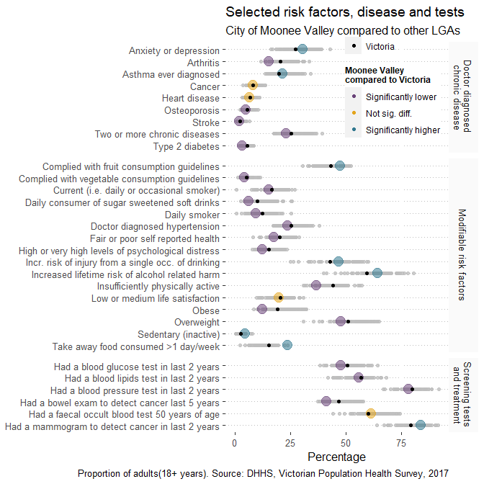

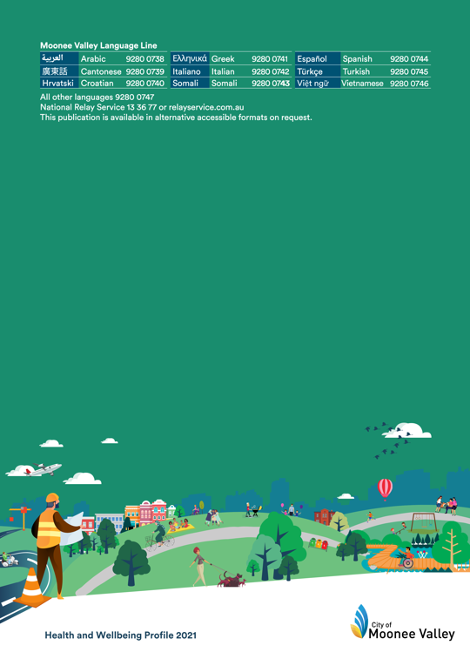

Essendon Fields does not have a residential population as is commonwealth land therefore Moonee Valley has no jurisdiction over what happens in this location.
This figure for international students is based on ‘non-citizen’ students from the 2016 Census, and therefore may include other types of visa holders, such as permanent residents in addition to those on a specific student visa.
source https://willingness.com.mt/health-behaviour-and-health-promotion-part-1-2/
The urban heat island (UHI) measure was derived from land surface temperature (LST) data based on Landsat 8 thermal infrared data collected by the United States Geological Survey (USGS).

